CONTENTS
1.0 ABOUT THINKTESTS 8
1.1 Exam Preparation for Every Student 8
1.2 Mock Test 8
1.3 Daily Practice 8
1.4 Custom Modules 8
1.5 Exams Info 8
2.0 PERSONA 9
2.1 For institutions 9
2.2 For Students 9
2.3 For Admin 9
3.0 ADMIN 10
3.1 Navbar 10
3.2 Dashboard 10
3.2.1 Overview 10
3.2.2 Active Institutions 10
3.2.3 Inactive Institutions 11
3.2.4 Active Subscribers 11
3.2.5 Inactive Subscribers 12
3.2.6 Upcoming Renewals 12
3.2.7 Total New Users 13
3.2.8 Test Utilization Report 14
3.2.9 Total Billing 14
3.2.10 Total Revenue 15
3.3 Subscribers 16
3.3.1 Overview 16
3.3.2 Filtering System 17
3.3.3 Subscriber Listing 18
3.3.4 Export Subscribers 19
3.3.5 Edit Subscribers 19
3.3.6 Delete Subscriber 21
3.4 Institutions 21
3.4.1 Overview 21
3.4.2 Filtering System 21
3.4.3 Institution Listing 22
3.4.4 Add Institution 23
3.4.5 Update Institution 24
3.4.6 Delete Institution 24
3.5 Coupon 24
3.5.1 Overview 24
3.5.2 Filtering System 25
3.5.3 Couponlist 26
3.5.4 Subscriber Listing 26
3.5.5 Activate coupon 27
3.5.6 Inactivate coupon 27
3.5.7 Edit coupon 27
3.5.8 Delete coupon 28
3.5.9 Add coupon 28
3.5.10 Create Coupon 29
3.5.11 Apply Coupon 29
3.6 Questions 30
3.6.1 Overview 30
3.6.2 Filtering System 30
3.6.3 Question Listing 31
3.6.4 Actions 32
3.6.5 Import Questions 32
3.6.6 Export all Questions 33
3.6.7 Export Questions 33
3.6.8 Add Question 33
3.7 Subjects 35
3.7.1 Overview 35
3.7.2 Filtering System 35
3.7.3 Subject Listing 36
3.7.4 Get Subject 36
3.7.5 Delete subject 37
3.7.6 Import Subjects 37
3.7.7 Export Subjects 37
3.7.8 Add Subject 37
3.7.9 Update Subject 38
3.8 Modules 38
3.8.1 Overview 38
3.8.2 Filtering System 39
3.8.3 Module Listing 39
3.8.4 Import Modules 40
3.8.5 Export Modules 40
3.8.6 Add Module 41
3.8.7 Get single Module 41
3.8.8 Update Module 41
3.8.9 Delete Module 42
3.9 Categories 42
3.9.1 Overview 42
3.9.2 Filtering System 42
3.9.3 Category Listing 43
3.9.4 Import Categories 44
3.9.5 Export Categories 44
3.9.6 Add Category 44
3.9.7 Get single Category 45
3.9.8 Update Category 45
3.9.9 Delete Category 45
3.10 Exams 45
3.10.1 Overview 45
3.10.2 Filtering System 46
3.10.3 Exam Listing 46
3.10.4 Add Exam 47
3.10.5 Update Exam 48
3.10.6 Delete Exam 50
3.11 Mock Exams 50
3.11.1 Overview 50
3.11.2 Filtering System 50
3.11.3 Mock Exam Listing 51
3.11.4 Import Mock Exam 51
3.11.5 Export Mock Exam 52
3.11.6 Add Exams 52
3.11.7 Edit Mock Exam 53
3.11.8 Delete Mock Exam 53
3.12 Logout 53
3.12.1 Overview 53
4.0 INSTITUTION 54
4.1 Navbar 54
4.2 Dashboard 54
4.2.1 Overview 54
4.2.2 Mock Tests 54
4.2.3 Daily Practice 55
4.2.4 Custom module 55
4.2.5 Performance Report 56
4.2.6 Students Performance 56
4.2.7 Mock Test pie chart 57
4.2.8 Daily Practice pie chart 58
4.2.9 Custom Module pie chart 58
4.2.10 Upcoming Exams 59
4.2.11 Exam Information 59
4.3 Performance Analysis 61
4.3.1 Overview 61
4.3.2 Mock Test 62
4.3.3 Filter Mock Test 62
4.3.4 Daily Practice 63
4.3.5 Filter Daily Practice 63
4.3.6 Custom Modules 64
4.3.7 Filter Custom Module 64
4.4 Exam Information 65
4.4.1 Overview 65
4.5 Profile 66
4.5.1 Overview 66
4.6 Logout 68
4.6.1 Overview 68
5.0 USER 68
5.1 Navbar 68
5.2 Dashboard 69
5.2.1 Overview 69
5.2.2 Mock Test 69
5.2.3 Daily Practice 69
5.2.4 Custom Modules 70
5.2.5 Take Test 70
5.2.6 My Scheduled 71
5.2.7 Performance Report 72
5.2.8 Mock Test Pie Chart 73
5.2.9 Daily Practice Pie Chart 73
5.2.10 Custom Modules Chart 74
5.2.11 Upcoming Exams 74
5.3 Mock Test 76
5.3.1 Overview 76
5.3.2 Exams Attempted 77
5.3.3 Average Score by Subject 78
5.3.4 Average Score by Difficulty Level 78
5.3.5 Completed test & Partially Completed 79
5.3.6 Mock Test Create 80
5.3.7 TakeTest 81
5.3.8 Mocktest Instruction 81
5.3.9 Submit Mocktest 82
5.3.10 Report 83
5.3.11 FilterReport 83
5.4 Daily Practice 84
5.4.1 Overview 84
5.4.2 Subjects Attempted 85
5.4.3 Average Score by Subject 86
5.4.4 Average Score by Difficulty Level 86
5.4.5 View Schedule 87
5.4.6 Completed, Partially Completed & Lapsed 89
5.4.7 Create daily practice test 90
5.4.8 DailyPractice Test 90
5.4.9 Delete dp attempt 90
5.4.10 Edit attempt date 91
5.4.11 DailyPractice Instruction 91
5.4.12 Submit DailyPractice 91
5.4.13 Report 92
5.4.14 FilterReport 93
5.5 Custom Modules 93
5.5.1 Overview 93
5.5.2 Subjects Attempted 94
5.5.3 Average Score by Subject 95
5.5.4 Average Score by Difficulty Level 95
5.5.5 Completed & Partially Completed 97
5.5.6 Create Custom Module test 98
5.5.7 Custom Module Test 98
5.5.8 Delete cm attempt 98
5.5.9 Custom Module Instruction 98
5.5.10 Submit Custom Module 99
5.5.11 Report 100
5.5.12 FilterReport 100
5.6 Exam Information 101
5.6.1 Overview 101
5.7 Profile 102
5.7.1 Overview 102
5.7.2 Renew Plan 103
5.7.3 Apply Coupon 104
5.7.4 Payment 104
5.7.5 Profile 105
5.8 Logout 107
5.8.1 Overview 107

1.0 - ABOUT THINKTESTS
1.1 Exam Preparation for Every Student
One platform, one fee – comprehensive test preparation that removes barriers to excellence
Quality exam preparation should not depend on your location or budget. We have built a single platform that delivers everything students need – mock tests, daily practice, and custom modules – under one affordable fee structure.
1.2 Mock Test
Real time exam simulations with performance analytics and detailed solutions - Mock tests provide a structured way to prepare for exams by simulating real-time conditions and offering detailed performance insights. Before starting, users select their target exam and difficulty level, choosing between full-length simulations or focused subject tests. During the test, they navigate time constraints and pacing decisions while the system automatically saves progress to prevent data loss. After completion, immediate scoring and comprehensive solution reports are available, including subject-wise performance scores, personalized recommendations, and enabling targeted improvement and effective exam readiness.
1.3 Daily Practice
Calendar tracking with instant feedback and flexible question selection - Daily Practice helps you build consistent exam readiness through calendar-based tracking, instant feedback, and flexible question selection. During the initial setup, you define your exam timeline and study hours, select subjects and modules for regular practice, configure test frequency and session parameters, review your generated practice calendar, and add up to 50 questions per session. As you progress, your complete sessions within designated time windows, track performance patterns, and adjust scheduling for convenience. All session results integrate seamlessly into overall progress tracking, helping you identify topics that need more focus while the calendar view visually highlights performance trends and improvement areas.
1.4 Custom Modules
Diagnostic analytics for test practice that adapts to your specific knowledge gaps - Custom Modules offer adaptive diagnostic analytics that tailor your practice to your specific knowledge gaps. You begin by selecting subjects and modules for your session, adding questions by difficulty level, setting a total question count of up to 100, and configuring subject distribution and difficulty balance. After completing the session, you can analyse results through detailed performance, downloadable reports for reference, and comparative performance across subjects and difficulty levels to guide focused improvement.
1.5 Exams Info
Chart your course to success with evert exam detail at your fingertips - Mock tests, daily practice, and custom modules designed for success in SOF National Science Olympiad and International Mathematics Olympiad
8
2.0 - PERSONA
2.1 For Institutions
Transform your school's competitive exam results, Want your students to crack top competitive exams consistently? Thinktests integrates CBSE/ICSE curriculum, providing you with insights into each student’s preparation level and enabling you to guide them more effectively.
What we provide:
- Comprehensive reporting for each student
- School-wide performance analytics
- Customizable practice sessions
- Tools to identify and nurture your top performers
2.2 For Students
Understand your performance and improve efficiently, Every test you take teaches our system about your strengths and weaknesses. Instead of random practice, you get targeted questions on topics where you need the most work. Detailed analytics show your percentile ranking, error patterns, and concrete improvement over time across every subject and topic.
What you will track:
- Performance comparisons against platform averages
- Downloadable PDF reports for offline review
- Subject-wise breakdowns revealing specific weak spots
- Average time spent tracking per section
2.3 For Admin
Manage the status of institutions and the subscribers list, Thinktests gives administrators a complete overview of institution status and subscriber engagement. It provides detailed metrics on user activation status, plan details, and validation for subscribers and institutions. Admin manages the exam info, questions, subjects, modules for every tests.
What you will track:
- Track active/inactive subscribers and institution.
- Downloadable pdf reports for viewing list of subscribers.
- Plan validity and enrolment dates for both subscribers and institutions.
- Total number of students available in single institution.
9
3.0 - ADMIN

3.1 Navbar
Admin navbar totally consists of ,



1. Dashboard 2. Subscribers 3. Institutions



4. Coupon 5. Payment 6 . Questions
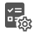
7. Subjects 8. Modules 9. Categories



10. Exams 11. Mock Exams 12. Logout

3.2 Dashboard
3.2.1 Overview
The Dashboard is a comprehensive analytics platform designed to visualize user activity, institutional engagement, billing performance, revenue generation, and upcoming renewals.
It leverages Apex Charts for dynamic visualization and integrates multiple REST APIs to provide real-time, filterable data. The dashboard aims to deliver actionable insights through interactive charts and well-defined metrics to support data-driven decision-making.

3.2.2 Active Institutions
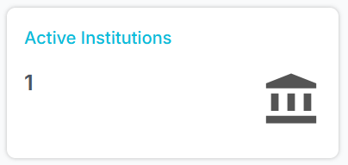
Shows institutions with active subscriptions. Provides insight into engagement levels.
- API: /AdminDashboard
- Methods: 'GET', 'POST'
- Function: adminDashboard()
- Request: 'user_id'
- Response: active_institutions=active_institutions

10
3.2.3 Inactive Institutions
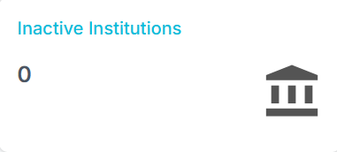
Shows institutions without active subscriptions. Helps identify institutions needing attention.
- API: /AdminDashboard
- Methods: 'GET', 'POST'
- Function: adminDashboard()
- Request: 'user_id'
- Response: inactive_institutions=inactive_institutions

3.2.4 Active Subscribers
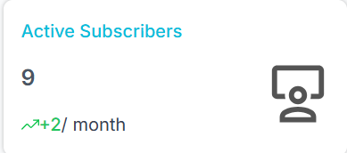
b
a
Users with ongoing subscriptions. Displays engagement and subscription activity.
- API: /AdminDashboard
- Methods: 'GET', 'POST'
- Function: adminDashboard()
- Request: 'user_id'
- Response: active_subscribers=active_subscribers // a
delta_active_subscribers // b
- Formula:delta_active_subscribers=active_subscribers-last_month_active_subscribers
- Explanation: delta_active_subscribers is difference between current months active subscriber and last month active subscriber. .Ex: Lets assume last month is Oct 2025 and active subscriber is 10 similarly current month is Nov 2025 and active subscriber is 15 then delta active subscriber 5 (15-10).

11
3.2.5 Inactive Subscribers
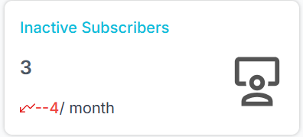
b
a
Users whose subscriptions have expired. Highlights churned or inactive users.
- API: /AdminDashboard
- Methods: 'GET', 'POST'
- Function: adminDashboard()
- Request: 'user_id'
- Response: inactive_subscribers=inactive_subscribers //a
delta_inactive_subscribers //b
- Formula: inactive_subscribers-last_month_inactive_subscribers

3.2.6 Upcoming Renewals
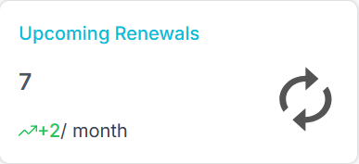
Subscriptions nearing expiry. Enables proactive engagement for renewals.
- API: /AdminDashboard
- Methods: 'GET', 'POST'
- Function: adminDashboard()
- Request: 'user_id'
- Response: upcoming_renewals=upcoming_renewals //a
delta_upcoming_renewals //b
- Formula: delta_upcoming_renewals=upcoming_renewals-last_month_renewals

12

3.2.7 Total New Users
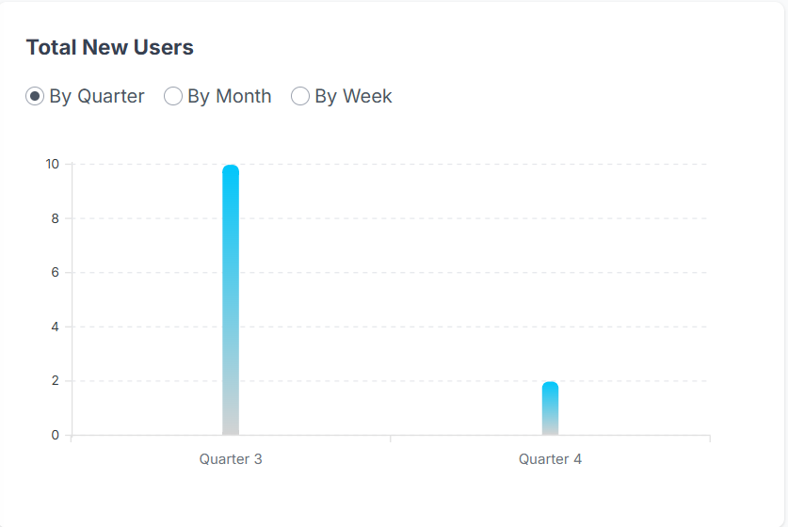
Newly registered users in a given period. Shows platform growth trends.
For Quarter ,
- API: /BarChartUsersQuarter // Apis are not secured
- Function: chart_users_quarter()
- Request:
- Response: QUARTER (grouped data)

For Month ,
- API: /BarChartUsersMonth
- Function: chart_users_month()
- Request:
- Response: MONTH (grouped data)

For Week ,
- API: /BarChartUsersWeek
- Function: chart_users_week()
- Request:
- Response: WEEK (grouped data)

13
3.2.8 Test Utilization Report
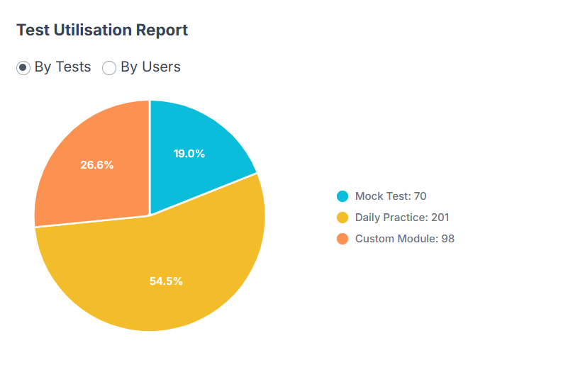
Tracks the number of tests taken by users or institutions. Useful for measuring engagement.
For Tests ,
- API: /PieChartTests // Apis are not secured
- Function: pie_chart_tests()
- Request:
- Response:"labels": labels, "series": series

For Users ,
API: /PieChartUsers
- Function: chart_users_week()
- Request:
- Response:"labels": labels, "series": series

3.2.9 Total Billing
Total billing generated over a selected period. Shows financial performance of the platform.
For Quarter ,

14
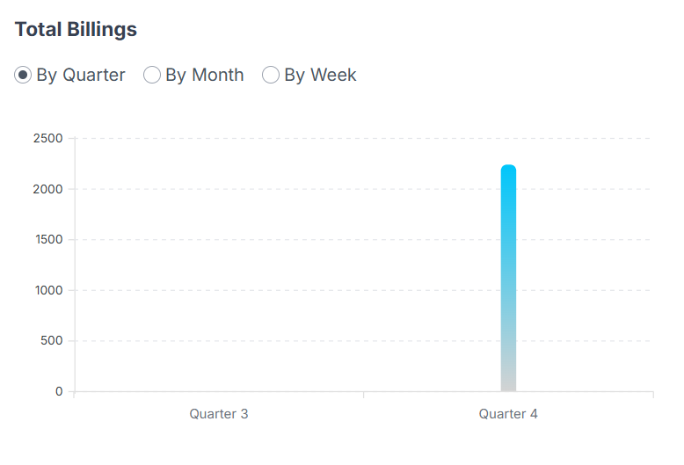

- API: /BarChartBillingsQuarter // Apis are not secured
- Function: chart_billings_q()
- Request:
- Response: QUARTER (grouped data)
For Month ,
- API: /BarChartBillingsMonth
- Function: chart_billings_m()
- Request:
- Response: MONTH (grouped data)
For Week ,
- API: /BarChartBillingsWeek
- Function: chart_billings_w()
- Request:
- Response: WEEK (grouped data)

3.2.10 Total Revenue
Total revenue collected in a period. Tracks overall business health and trends. For Quarter ,

15
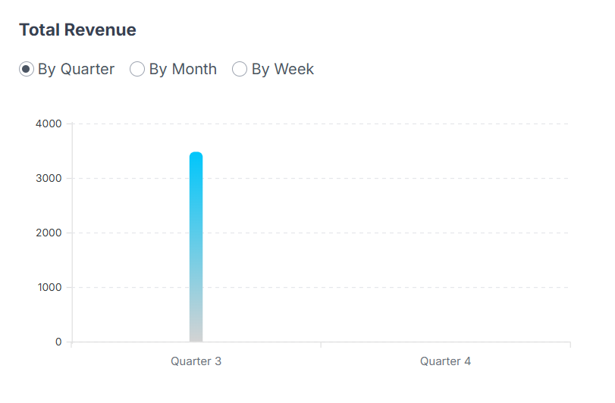
- API: /BarChartRevenueQuarter // Apis are not secured
- Function: chart_users_quarter()
- Request:
- Response: QUARTER (grouped data)
For Month ,
- API: /BarChartRevenueMonth
- Function: chart_revenue_m()
- Request:
- Response: MONTH (grouped data)
For Week ,
- API: /BarChartRevenueWeek
- Function: chart_revenue_w()
- Request:
- Response: WEEK (grouped data)

3.3 Subscribers
3.3.1 Overview
The Admin Subscriber module provides a centralized interface for administrators to view, filter and manage all subscribers in the system. It allows filtering by user name, institution, plan, status and enrolment date, alone with real-time updates and export capabilities.

16
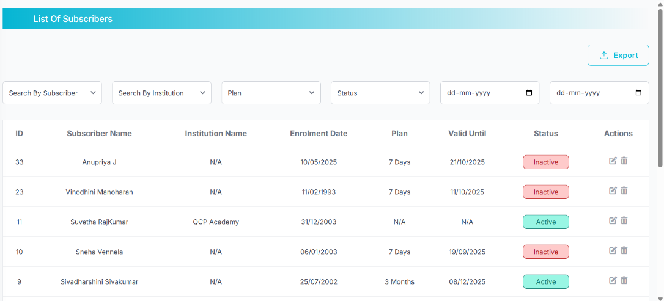
b
a
c
3.3.2 Filtering System
Admins can filter subscribers by , // a
- Subscriber name
- Institution name
- Plan type
- Status (Active / Inactive)
- Enrolment date range
    - API: /AdminSubscriberList
    - Methods: 'GET', 'POST'
    - Function: adminSubscriberList()
    - Request: 'user_id'
    - Response: students=student_list,
page=page,
total_pages=pagination.pages,
has_prev=pagination.has_prev,
has_next=pagination.has_next,
prev_num=max(1, pagination.page - BLOCK_SIZE),
next_num=min(pagination.pages, pagination.page + BLOCK_SIZE),
block_start=block_start,
block_end=block_end,
plan_options=plan_options,
17
subscribers=[{"id": s[0], "name": f"{s[1]} {s[2]}"} for s
in subscribers],
institutions=[{"id": i[0], "name": i[1]} for i in institutions],
current_filters={
'search_name': search_name,
'search_institution': search_institution,
'plan': selected_plan,
'status': selected_status,
'enrol_from': enrol_from,
'enrol_to': enrol_to
}
For getsubscriber ,
- API: /getSubscriber
- Methods: 'GET'
- Function: getSubscriber()
- Request: user_id
- Response: 'student_id': student.student_id,
'first_name': student.first_name,
'last_name': student.last_name,
'institution_id': student.institution_id

3.3.3 Subscriber Listing //b
- ID
- Subscriber Name
- Institution Name
- Enrolment Dates
- Plan
- Valid Until

18
- Status (Active/Inactive)
- Actions
- API: /AdminSubscriberPartial //Directly taken from DB
- Methods: 'GET'
- Function: adminSubscriberPartial()
- Request: 'user_id'
- Response: students=student_list,
page=page,
total_pages=pagination.pages,
has_next=pagination.has_next,
has_prev=pagination.has_prev,
next_num=min(pagination.pages, pagination.page + BLOCK_SIZE),
prev_num=max(1, pagination.page - BLOCK_SIZE),
block_start=block_start,
block_end=block_end

3.3.4 Export Subscribers //c
Allows exporting filtered subscriber data into a report file and export link dynamically updates according to current filter parameter.
- API: /exportSubscribers
- Methods: ‘GET’
- Function: exportSubscribers()
- Request:
- Response: Excel file which contains downloaded data
3.3.5 Edit Subscriber
Admin can edit the subscriber details and after submitting, the updated one shows in the list of subscribers.

19
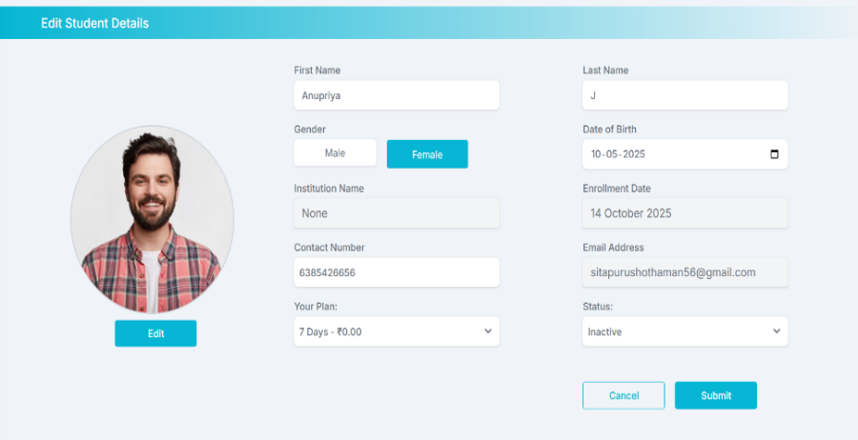

- API: /AdminEditSubscriber
- Methods: 'GET'
- Function: adminEditSubscriber()
- Request: student_id
- Response: student=student,
subscription=subscription_data,
current_plan=current_plan_name,
subscription_status=subscription_status,
institution_name=institution_name,
plan_options=plan_options,
profile_pic_url=profile_pic_url
For Profile pic , // Blob
- API: /uploadProfilePicEditSubscriber
- Methods: ‘POST’
- Function: upload_profile_pic_editsubscriber()
- Request: student_id
- Response:
For updatesubscriber ,
- API: /updateSubscriber
- Methods: ‘GET’
- Function:updateSubscriber()
20
- Request: student_id
- Response: 'student_id': student.student_id,
'first_name': student.first_name,
'last_name': student.last_name,
'institution_id': student.institution_id

3.3.6 Delete Subscriber
Allows the admin to remove a subscriber record. Upon confirmation, an API can delete the record and refreshes the table.
- API: /deleteSubscriber
- Methods: 'POST'
- Function: deleteSubscriber()
- Request: student_id
- Response: :

3.4 Institutions
3.4.1 Overview
The Admin Institution module enables administrators to manage all institutions within the system. It provides filtering, viewing, and deletion of institutions with dynamic updates, ensuring efficient and seamless data management.
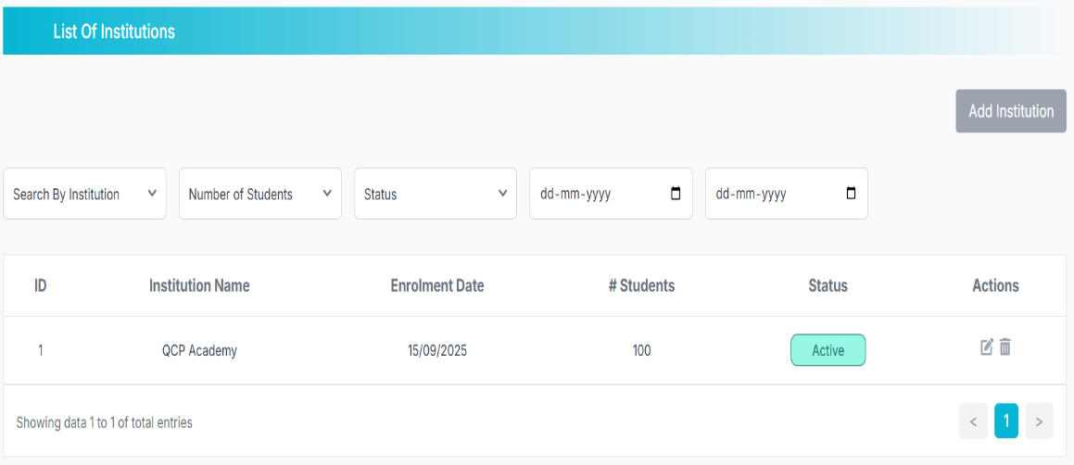
b
a
c
3.4.2 Filtering System //a
Displays a complete list of institutions with the following details ,
- Institution Name
21
- Number of Students
- Status (Active/Inactive)
- Enrolment Dates //Directly taken from DB datetime.today()
- API: /AdminInstitutionList // Apis are not secured
- Methods: ’GET’
- Function: adminInstitutionList()
- Request:
- Response: institution_names=institution_names,
plan_options=plan_options,
current_filters={
'search_institution': request.args.get('search_institution', ''),
'plan': request.args.get('plan', ''),
'no_of_students': request.args.get('no_of_students', ''),
'status': request.args.get('status', ''),
'enrol_from': request.args.get('enrol_from', ''),
'enrol_to': request.args.get('enrol_to', '')
}
3.4.3 Institution Listing //b
- ID
- Institution Name
- Enrolment Date
- #Students
- Status (Active/Inactive)
- Actions
- API: /AdminInstitutionPartial // Apis are not secured
- Methods: ’GET’ //Directly taken from DB
- Function: adminInstitutionPartial()

22
- Request:
- Response: result

3.4.4 Add Institution //c
Provides navigation to an institution creation page where new institutions can be registered.
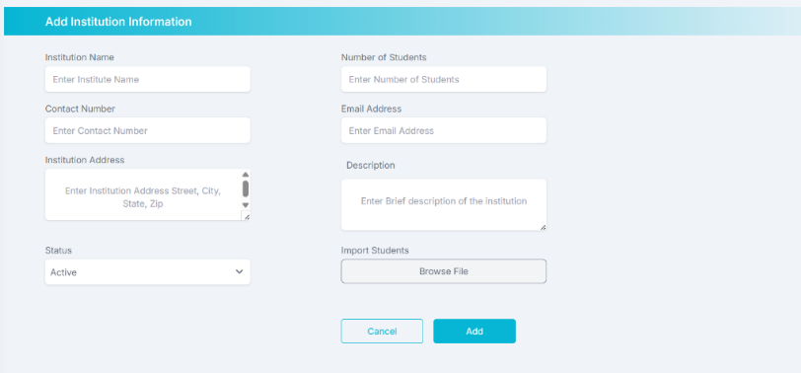
API: /addInstitution
Methods: "GET", "POST"
Function: addInstitution()
Request: name = request.form.get('name')
contact_no = request.form.get('contact_no')
email = request.form.get('email')
no_of_students = int(request.form.get('no_of_students', 0))
address = request.form.get('address')
description = request.form.get('description')
# plan_id = int(request.form.get('plan'))
is_active = request.form.get('status') == 'true'
file = request.files.get('file')
Response: institution_id = institutionLogin.institution_id,
institution_name=name,
no_of_students=no_of_students,
contact_no=contact_no,
email=email,
address=address,
23
description=description,
password=hashed_password,
enrolment_date=datetime.today()

3.4.5 Update Institution
Allows the administrator to updates institutions from the system.
API: /updateInstitution
Methods: "GET", "POST"
Function: updateInstitution()
Request: institution_id = request.form.get('institution_id')
institution = Institution.query.get(institution_id)
subscription=InstitutionSubscription.query.filter_by(institution_id=institution_id)
.first()
Response: institution=institution,
subscription=subscription,
subscription_status=subscription_status

3.4.6 Delete Institution
Allows the administrator to remove institutions from the system.
API: /deleteInstitution
Methods: 'POST'
Function: deleteInstitution(institution_id)
Request: institution_id
Response:

3.5 Coupon
3.5.1 Overview
The Admin Coupon module allows administrators to manage all coupon codes available within the platform. It enables filtering, creation, and analysis of coupon data using dynamic based updates, providing a responsive and efficient user experience.
24
Action has active/inactive, edit, and delete options
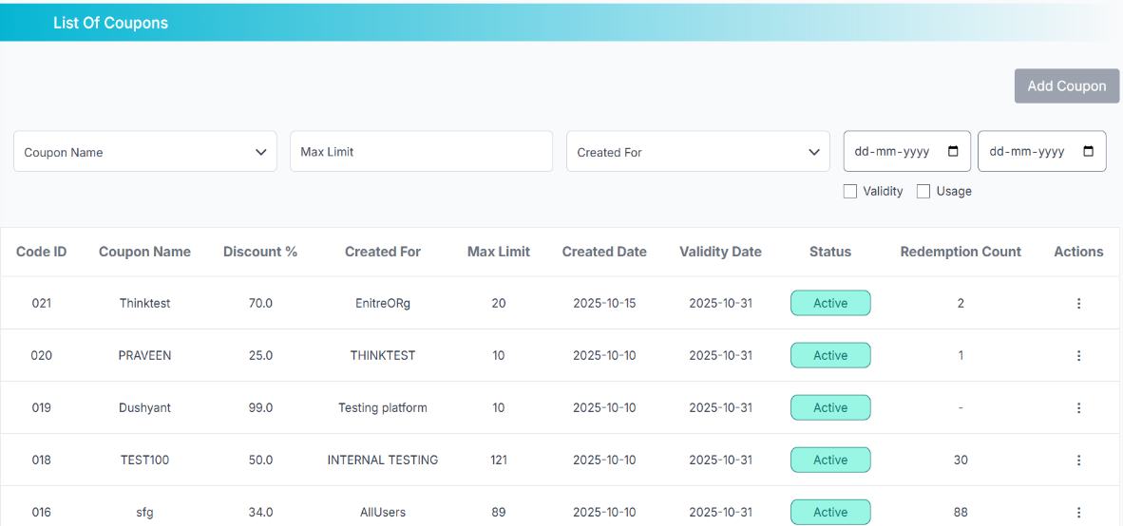
b
a
c

3.5.2 Filtering System //a
The filtering system supports:
- Coupon Name
- Max Limit
- Created For
- Date Range
- Validity / Usage Checkboxes
- API: /adminCouponList // Apis are not secured
- Methods: ‘GET’
- Function: admin_coupon_list()
- Request:
- Response: coupons=coupons,
page=page,
total_pages=total_pages,
block_start=block_start,
block_end=block_end,
current_filters=current_filters,
coupon_names=coupon_names,

25
usage_counts=usage_counts,
created_for_options=created_for_options

3.5.3 Couponlist
- API: /coupon/list
- Methods: ‘GET’
- Function: get_coupon_list()
- Request: page
limit
- Response: 'data': coupons,
'total_pages': query.pages,
'current_page': page

3.5.4 Subscriber Listing //b
- Coupon ID
- Coupon Name
- Discount %
- Created For
- Max Limit
- Created Date
- Validity Date
- Status (Active/Inactive)
- Redemption Count
- Actions
- API: /adminCouponPartial // Apis are not secured
- Methods: ’GET’ //Directly taken from DB
- Function: adminCouponPartial()
- Request:
- Response: coupons=coupons,
page=page,
26
page=page,
total_pages=total_pages,
has_prev=has_prev,
has_next=has_next,
prev_num=prev_num,
next_num=next_num,
block_start=block_start,
block_end=block_end,
limit=per_page,
current_filters=current_filters
3.5.5 Activate coupon
- API: /coupon/<codeid>/activate
- Methods: 'PUT'
- Function: activate_coupon(codeid)
- Request: codeid
- Response:
3.5.6 Inactive coupon
- API: /coupon/<codeid>/deactivate
- Methods: 'PUT'
- Function: deactivate_coupon(codeid)
- Request: codeid
- Response:
3.5.7 Edit coupon
- API: /coupon/<codeid>/edit
- Function: edit_coupon(codeid)
- Methods: 'PUT'
- Request: codeid
- Response:
Update fields only if present ,
27
- Request: CouponCodeName
CreatedFor
Status
ValidityDate

Validate and update discount ,
- Request: DiscountPercent

Validate and update usage count ,
- Request: UsageCount

3.5.8 Delete coupon
- API: /coupon/<codeid>/delete
- Methods: 'DELETE'
- Function: delete_coupon(codeid)
- Request: codeid
- Response:

3.5.9 Add coupon //c
Redirects to a form for creating new coupons.
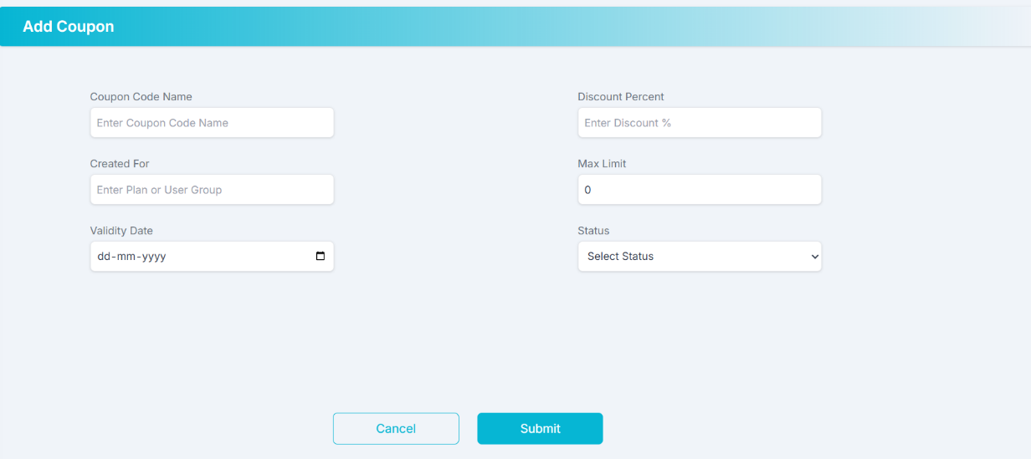

28

- API: /addcoupon //get coupon details after click of edit button
- Methods: ‘GET’
- Function: addcoupon()
- Request: edit_id
- Response: coupon=coupon
3.5.10 Create Coupon
- API: /coupon/create
- Methods: 'POST'
- Function: create_coupon()
- Request: CouponCodeName
DiscountPercent
CreatedFor
ValidityDate
Status
- Response: 'message': 'Coupon created successfully',
'CodeId”': new_coupon.codeid,
'CreatedDate': new_coupon.createddate.isoformat()

3.5.11 Apply Coupon
- API: /coupon/apply
- Methods: 'POST'
- Function: apply_coupon()
- Request: coupon_code
original_price
- Response: 'message': f'Coupon "{coupon_code}" applied successfully',
'original_price': original_price,
'discount_percent': float(coupon.discountpercent),
'discount_amount': round(discount_amount, 2),
'final_price': round(final_price, 2),
29
'code_id': coupon.codeid,
'usage_counter': coupon.usagecounter,
'usage_limit': coupon.usagecount

3.6. Questions
3.6.1 Overview
The Admin Question allows administrators to manage all question entries available within the platform. It enables importing, exporting, filtering, creation, and deletion of questions using dynamically updated data, ensuring a responsive and efficient user experience. Actions include like import, export, add new question, and delete existing questions.
e
f
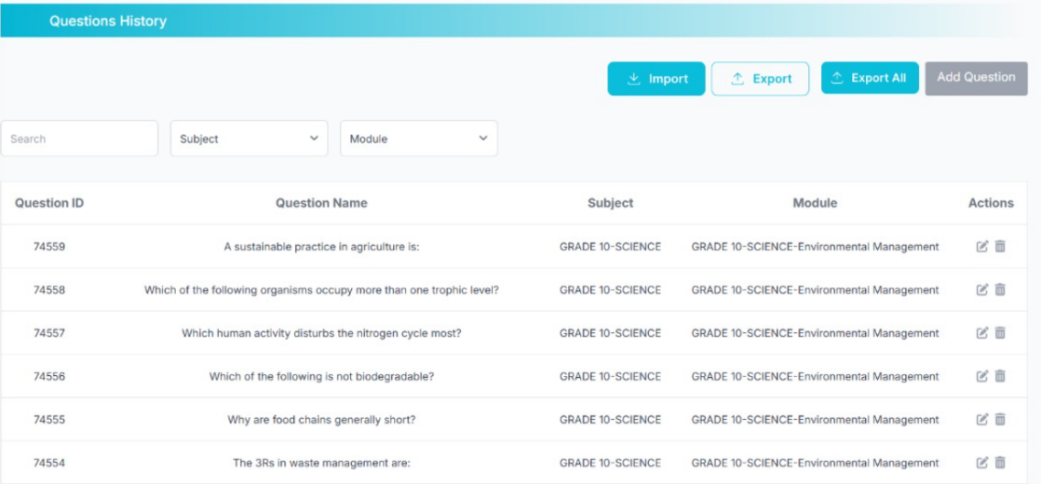
b
a
d
c

3.6.2 Filtering System //a
The filtering system supports:
- Search by Question Name , Question ID
- Subject
- Module
- API: /AdminQuestionList // Apis are not secured
- Methods: ‘GET’
- Function: adminQuestionList()
- Request:
- Response: questions=questions,
subjects=subjects,
30
modules=modules,
current_filters={'subject':request.args.get('subject', ''), 'module': request.args.get('module', '')},
page=pagination.page,
total_pages=pagination.pages,
has_prev=pagination.has_prev,
has_next=pagination.has_next,
prev_num=max(1, pagination.page - BLOCK_SIZE),
next_num=min(pagination.pages,pagination.page+BLOCK_SIZ),
block_start=block_start,
block_end=block_end)

3.6.3 Question Listing //b
Each question entry contains key metadata and management actions.
- Question ID
- Question Name
- Subject
- Module
- Actions (Edit / Delete)
- API: /AdminQuestionPartial // Apis are not secured
- Methods: ‘GET’ //Directly taken from DB
- Function: adminQuestionPartial()
- Request:
- Response: questions=questions,
page=pagination.page,
total_pages=pagination.pages,
has_prev=pagination.has_prev,
has_next=pagination.has_next,
31
prev_num=max(1, pagination.page - BLOCK_SIZE),
next_num=min(pagination.pages, pagination.page + BLOCK_SIZE),
block_start=block_start,
block_end=block_end

3.6.4 Actions
- For edit ,
- API: /adminEditQuestion
- Methods: 'GET', 'POST'
- Function: adminEditQuestion()
- Request: 'q_id'
- Response: question=question,
subjects=subjects,
modules=modules,
directions=directions,
subject_module_mappings = subject_module_mappings

- For delete ,
- API: /deleteQuestion
- Methods: 'POST'
- Function: deleteQuestion()
- Request: 'question_id'
- Response:
3.6.5 Import Questions //e
Upload files to add multiple questions.
- API: /importQuestions
- Methods: 'POST'
- Function: importQuestions()
32
- Request: 'file' //Excel /CSV files
- Response:
3.6.6 Export all Questions //d
Download all the question data.
- API: /exportQuestions // Apis are not secured
- Methods: ‘GET’
- Function: exportQuestions()
- Request:
- Response: Excel file contains downloaded data
3.6.7 Export Questions //f
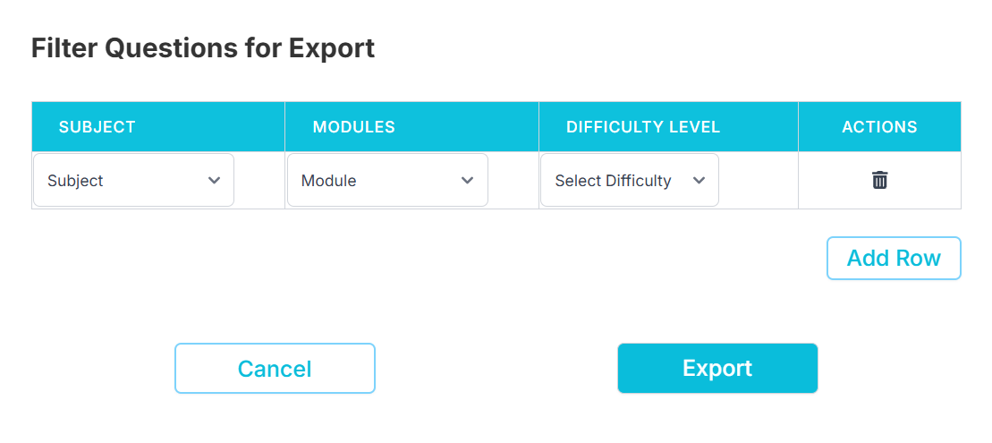
- API: /exportQuestionsFiltered // Apis are not secured
- Methods: ‘GET’
- Function: exportQuestionsFiltered()
- Request:
- Response: Excel file contains downloaded data
3.6.8 Add Question //c
Redirects administrators to the form for adding a new question.

33
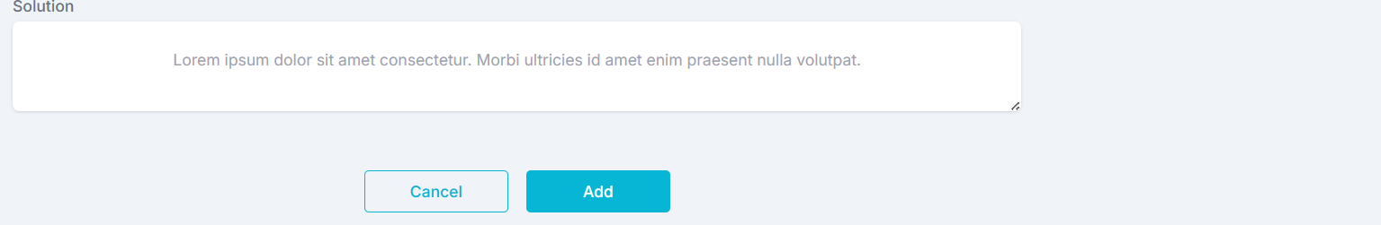
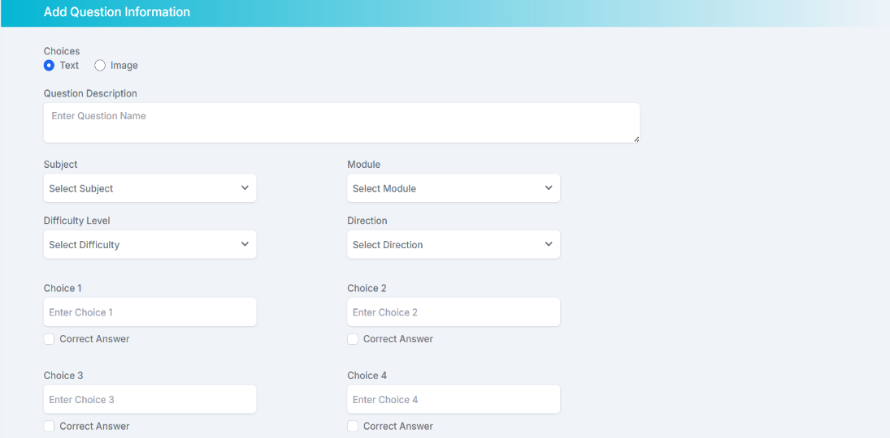

- API: /adminAddQuestion
- Methods: 'GET', 'POST'
- Function: adminAddQuestion()
- Request: name = request.form.get('name')
subject_id = request.form.get('subject')
module_id = request.form.get('module')
direction_id = request.form.get('direction')
difficulty_level = request.form.get('difficulty')
answer_options = request.form.get('answer_options')
choice_type = request.form.get('type')
multi_select = request.form.get('multi_select') == 'true'
correct_option = request.form.get('correct_option')
solution = request.form.get('solution')
- Response: subjects=subjects,
modules=modules,
directions=directions,
subject_module_mappings = subject_module_mappings
34
3.7 Subjects
3.7.1 Overview
The Admin Subject module allows administrators to manage all subjects in the system efficiently. It provides dynamic functionality for filtering, adding, editing, importing, exporting, and deleting subjects, with full integration for module mapping under each subject.
e
d
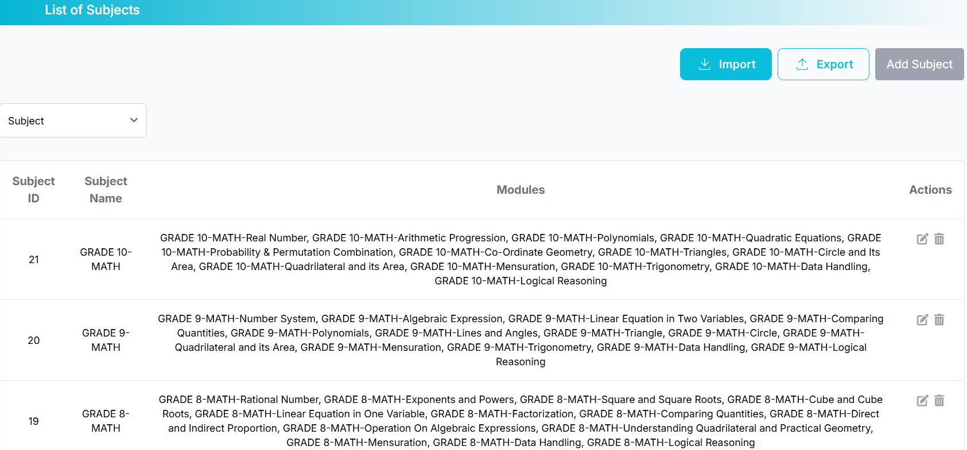
b
c
a
3.7.2 Filtering System //a
The filtering system supports:
- Subject
- API: /AdminSubjectList //APIs are not secured
- Function: adminSubjectList()
- Methods: ‘GET’
- Request:
- Response: subjects=subject_data,
page=page,
total_pages=pagination.pages,
prev_num=max(1, pagination.page - BLOCK_SIZE),
next_num=min(pagination.pages, pagination.page + BLOCK_SIZE),
has_prev=pagination.has_prev,
has_next=pagination.has_next,
block_start=block_start,
block_end=block_end,
current_filters={'subject': subject_filter},

35
all_subjects=all_subjects,
all_modules=all_modules

3.7.3 Subject Listing //b
Each subject entry displays essential information, including linked modules and available actions.
1. Subject ID
2. Subject Name
3. Modules
4. Actions (Edit/Delete)
- API: /AdminSubjectPartial //APIs are not secured
- Methods: ‘GET’ //Directly taken from DB
- Function: adminSubjectPartial()
- Request:
- Response: subjects=subject_data,
page=page,
total_pages=pagination.pages,
prev_num=max(1, pagination.page - BLOCK_SIZE),
next_num=min(pagination.pages, pagination.page + BLOCK_SIZE),
has_prev=pagination.has_prev,
has_next=pagination.has_next,
block_start=block_start,
block_end=block_end

3.7.4 Get Subject
- API: /getSubject
- Methods: ‘POST’ , ‘GET’
- Function: getSubject(subject_id)
- Request: subject_id
36
- Response: 'subject_id': subject.subject_id,
'subject_name': subject.subject_name,
'modules': module_data
3.7.5 Delete subject
- API: /deleteSubject
- Methods: 'POST'
- Function: deleteSubject()
- Request: subject_id
- Response:
3.7.6 Import Subjects //e
Upload files to add multiple subject.
- API: /importSubjects
- Methods: 'POST'
- Function: importSubjects()
- Request: 'file' //Excel /CSV files
- Response:
3.7.7 Export Subjects //d
Download all the subject data.
- API: /exportSubjects // Apis are not secured
- Function: exportSubjects()
- Request:
- Response: Excel file contains downloaded data
3.7.8 Add Subject //c
Redirects administrators to the form for adding a new question.

37
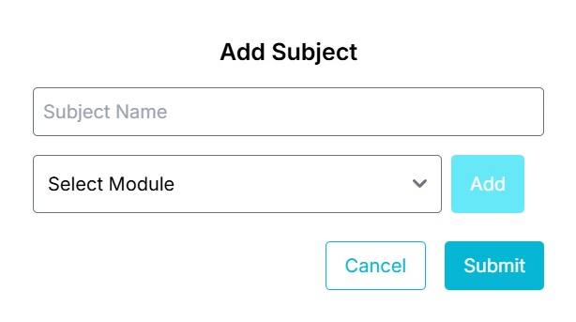
- API: /addSubject
- Methods: 'POST'
- Function: addSubject()
- Request: 'subject_name'
'module_ids'
- Response:
3.7.9 Update Subject
- API: /updateSubject
- Methods: 'POST'
- Function: updateSubject()
- Request: subject_id
subject_name
module_ids
- Response:

3.8 Modules
3.8.1 Overview
The Admin Module provides administrators with full control to view, add, edit, delete, import, and export modules. . It provides dynamic functionality for filtering module.

38
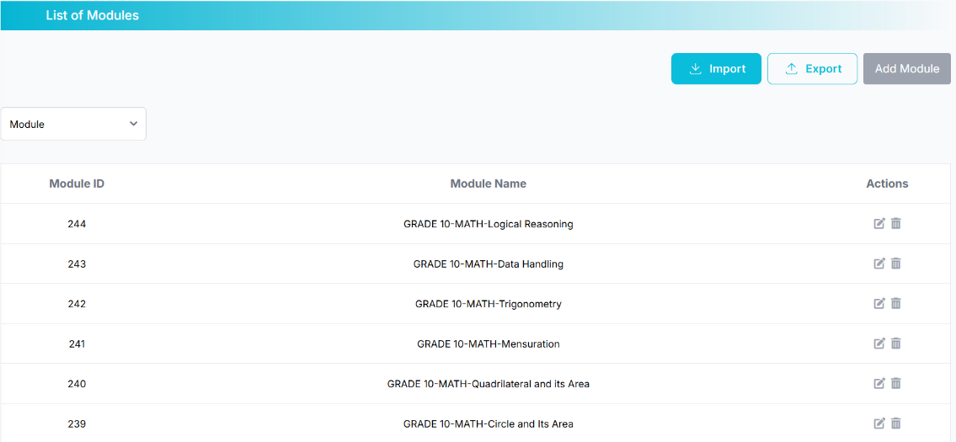
e
d
b
c

a
3.8.2 Filtering System //a
The filtering system supports:
- Module
- API: /AdminModuleList //APIs are not secured
- Methods: ‘GET’
- Function: adminModuleList()
- Request:
- Response: modules=modules,
all_modules=all_modules,
page=page,
total_pages=pagination.pages,
prev_num=max(1, pagination.page - BLOCK_SIZE),
next_num=min(pagination.pages, pagination.page + BLOCK_SIZE),
has_prev=pagination.has_prev,
has_next=pagination.has_next,
block_start=block_start,
block_end=block_end,
current_filters={'module_id': module_id})
3.8.3 Module Listing //b
Each subject entry displays essential information, including linked modules and available actions.

39
1. Module ID
2. Module Name
3. Actions (Edit/Delete)
- API: /AdminModulePartial //APIs are not secured
- Methods: ’GET’ //Directly taken from DB
- Function: adminModulePartial()
- Request:
- Response: modules=modules,
page=page,
total_pages=pagination.pages,
prev_num=max(1, pagination.page - BLOCK_SIZE),
next_num=min(pagination.pages, pagination.page + BLOCK_SIZE),
has_prev=pagination.has_prev,
has_next=pagination.has_next,
block_start=block_start,
block_end=block_end

3.8.4 Import Modules //d
Upload files to add multiple module.
- API: /importmodules
- Methods: 'POST'
- Function: importmodules()
- Request: 'file' //Excel /CSV files
- Response:
3.8.5 Export Modules //e
Download all the module data.
- API: /exportmodules
- Methods: ‘GET
40
- Function: exportmodules()
- Request:
- Response: Excel file contains downloaded data
3.8.6 Add Module //c
Redirects administrators to the form for adding a new module.
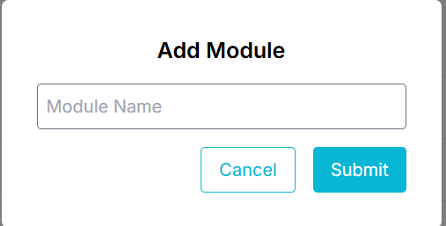
- API: /addModule
- Methods: 'POST'
- Function: addModule()
- Request: 'module_name'
- Response:
3.8.7 Get single Module
- API: /getModule
- Methods: ‘POST’ , ‘GET’
- Function: getModule(module_id)
- Request: module_id
- Response: 'module_id': module.module_id,
'module_name': module.module_name
3.8.8 Update Module
- API: /updateModule
- Methods: 'POST'
- Function: updateModule()

41
- Request: module_id
module_name
- Response:
3.8.9 Delete Module
- API: /deleteModule
- Methods: 'POST'
- Function: deleteModule()
- Request: module_id
- Response:

3.9 Categories
3.9.1 Overview
The Admin Category page allows administrators to select the category using filter option. It can add, edit, delete, import, and export categories. Admins can view category ID, name and actions like edit and delete.
e
d
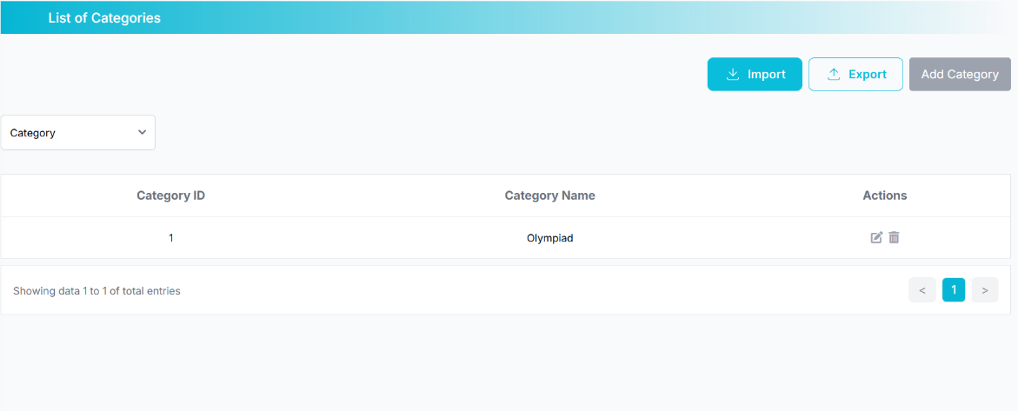
b
a
c
3.9.2 Filtering System //a
The filtering system supports:
- Category
- API: /AdminCategoryList //APIs are not secured
- Methods: ’GET’
42
- Function: adminCategoryList()
- Request:
- Response: categories=categories,
all_categories=all_categories,
page=page,
total_pages=pagination.pages,
prev_num=max(1, pagination.page - BLOCK_SIZE),
next_num=min(pagination.pages, pagination.page + BLOCK_SIZE),
has_prev=pagination.has_prev,
has_next=pagination.has_next,
block_start=block_start,
block_end=block_end,
current_filters={'category_id': category_id})
3.9.3 Category Listing //b
Each category entry displays essential information, including linked modules and available actions.
1. Category ID
2. Category Name
3. Actions (Edit/Delete)
- API: /AdminCategoryPartial //APIs are not secured
- Methods: ’GET’ //Directly taken from DB
- Function: adminCategoryPartial()
- Request:
- Response: categories=categories,
page=page,
total_pages=pagination.pages,
prev_num=max(1, pagination.page - BLOCK_SIZE),
next_num=min(pagination.pages, pagination.page + BLOCK_SIZE),
has_prev=pagination.has_prev,
43
has_next=pagination.has_next,
block_start=block_start,
block_end=block_end

3.9.4 Import Categories //d
Upload files to add multiple categories.
- API: /importcategories
- Methods: 'POST'
- Function: importcategories()
- Request: 'file' //Excel /CSV files
- Response:
3.9.5 Export Categories //e
Download all the categories data.
- API: /exportcatgories
- Methods: ‘GET’
- Function: exportcategories()
- Request:
- Response: Excel file contains downloaded data
3.9.6 Add Category //c
Redirects administrators to the form for adding a new category.
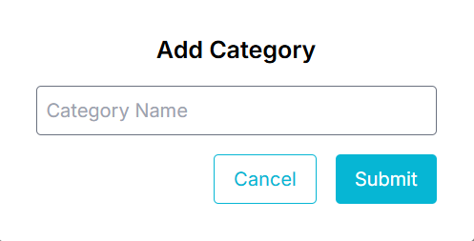
- API: /addCategory
- Methods: 'POST'
44
- Function: addCategory()
- Request: category_name
- Response:
3.9.7 Get single Category
- API: /getCategory
- Methods: ‘POST’ , ‘GET’
- Function: getCategory(category_id)
- Request: category_id
- Response: 'category_id': category.category_id,
'category_name': category.category_name
3.9.8 Update Category
- API: /updateCategory
- Methods: 'POST'
- Function: updateCategory()
- Request: category_id
category_name
- Response:
3.9.9 Delete Category
- API: /deleteCategory
- Methods: 'POST'
- Function: deleteCategory()
- Request: category_id
- Response:

3.10 Exams
3.10.1 Overview
The Admin Exam List page allows administrators to view and manage all exams within the system. Admins can filter, add, edit, delete, and navigate through paginated lists of exams.
45
Each exam displays detailed information including the Exam ID, Exam Name, Category, Updated On, and Updated By fields, with available actions such as edit and delete.
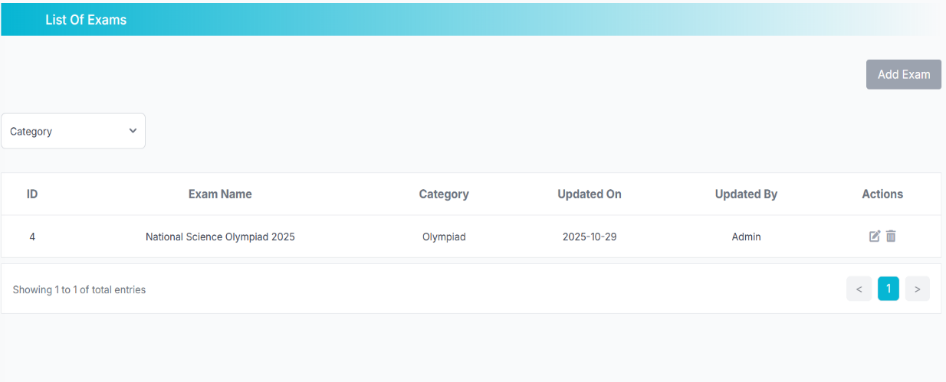
a
c
b
3.10.2 Filtering System //a
The filtering system supports:
- Category
- API:/AdminExamList // APIs are not secured
- Methods: ‘GET’
- Function: adminExamList()
- Request:
- Response: exams=exams, examcategories=examcategories,
page=page, total_pages=pagination.pages, prev_num=max(1, pagination.page - BLOCK_SIZE),
next_num=min(pagination.pages, pagination.page + BLOCK_SIZE), has_prev=pagination.has_prev, has_next=pagination.has_next,
block_start=block_start, block_end=block_end,
current_filters={'search_category': search_category}
3.10.3 Exam Listing //b
Each category entry displays essential information, including linked modules and available actions.
1. ID
2. Exam Name
3. Category
46
4. Updated on
5. Updated by
6. Actions(Edit/Delete)
- API: /AdminExamPartial //APIs are not secured
- Methods: ‘GET’ //Directly taken from DB
- Function: adminExamPartial()
- Request:
- Response:exams=exams,
page=page, total_pages=pagination.pages, prev_num=max(1, pagination.page - BLOCK_SIZE),
block_start=block_start, block_end=block_end,
next_num=min(pagination.pages, pagination.page + BLOCK_SIZE), has_prev=pagination.has_prev, has_next=pagination.has_next

3.10.4 Add Exam //c
Redirects administrators to a form for adding a new exam.
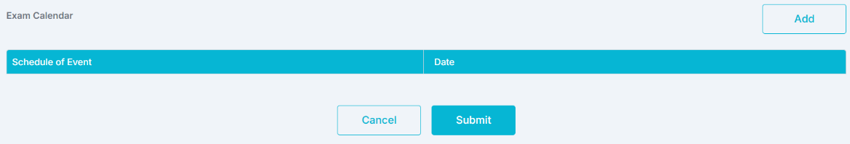
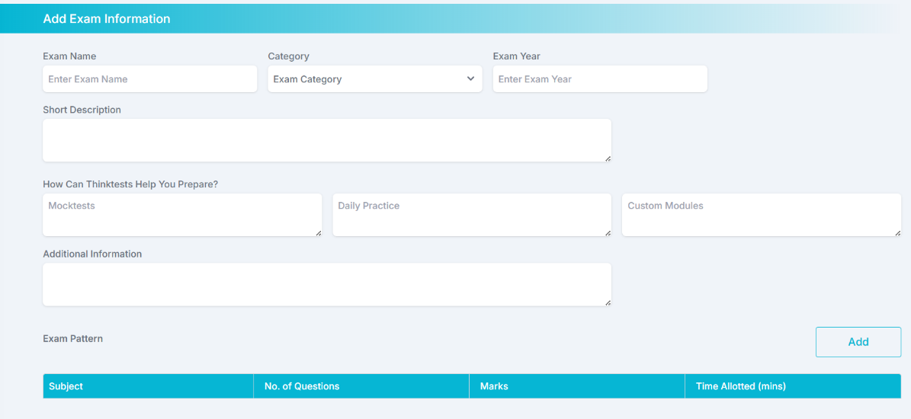

- API: /AddExam
47

- Methods: 'GET', 'POST'
- Function: addExam()
For create exam,
- Request: exam_name
category_id
exam_description
year
For prepare block,
- Request: mockdesc
dailydesc
customdesc
additionalinf
For exam pattern,
- Request: pattern_subjects[] or subject[]
pattern_questions or no_questions[]
pattern_marks[] or marks[]
pattern_time[] or time_alloted[]
For exam calender,
- Request: calendar_events[]
calendar_dates[]
Fallback to single-name inputs,
- Request: schedule_of_events
schedule_of_events
important_dates
important_dates
- Response: categories=categories
3.10.5 Update Exam
48
- API: /updateExam
- Methods: 'GET', 'POST'
- Function:updateExam(exam_id)
- Request: exam_name
category_id
exam_description
year
For prepare section,
- Request: mockdesc
dailydesc
customdesc
additionalinf
For patterns,
- Request: pattern_ids[]
pattern_subjects[]
pattern_questions[]
pattern_marks[]
pattern_time[]
For calender,
- Request: calendar_ids[]
calendar_events[]
calendar_dates[]

- Response: exam=exam,
prepare=prepare,
patterns=patterns,
calendars=calendars,
categories=categories
49

3.10.6 Delete Exam
- API: /deleteExam
- Methods: 'POST'
- Function: deleteExam()
- Request: exam_id
- Response:

3.11 Mock Test
3.11.1 Overview
The Admin Mock Exam page allows administrators to manage mock exams through search filters. Admins can add, edit, delete, import, and export mock exams efficiently. The list view shows essential details such as Exam ID, Exam Name, Duration, Instructions, and Difficulty Level.
e
d
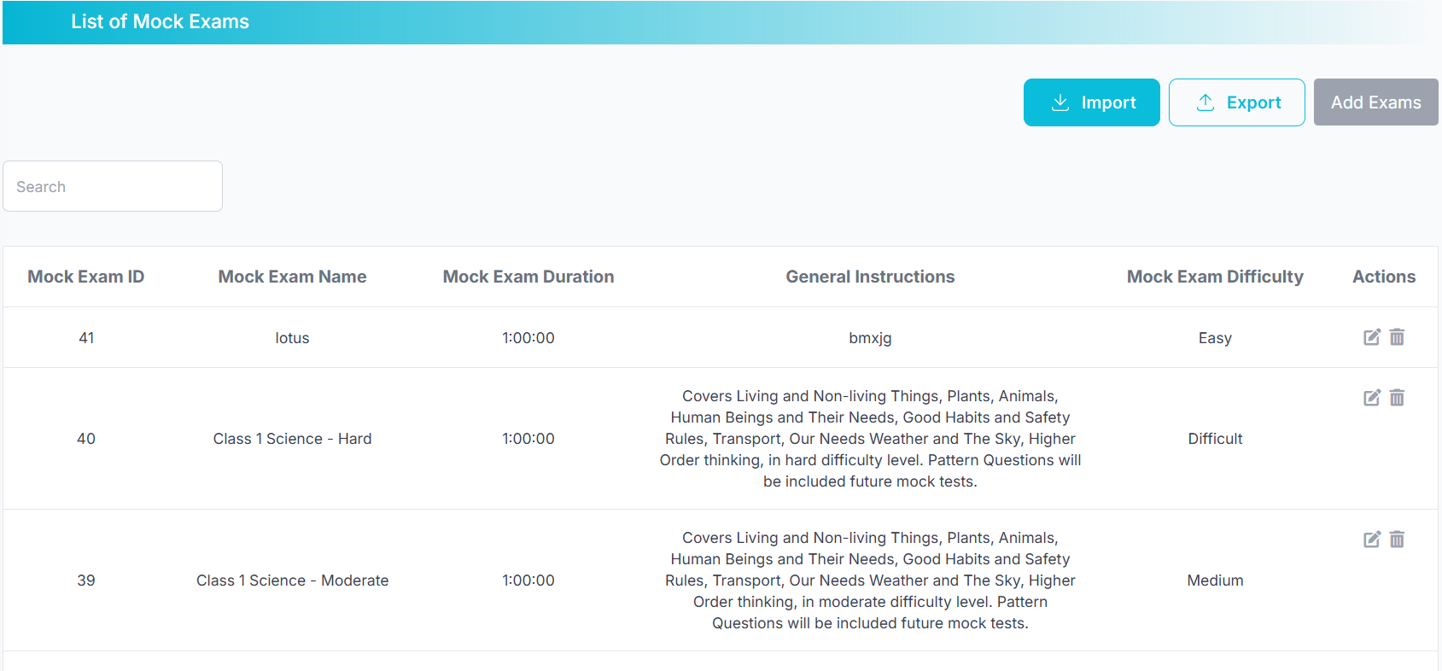
c
b
a
3.11.2 Filtering System //a
The filtering system supports:
- Search by exam name

- API: /AdminMockExamList //APIs are not secured
- Methods: ‘GET’
- Function: adminMockExamList()
50
- Request:
- Response: mockExams=pagination.items,
page=pagination.page, total_pages=pagination.pages,
has_next=pagination.has_next, has_prev=pagination.has_prev,
block_start=block_start, block_end=block_end,
next_num=min(pagination.pages, pagination.page + BLOCK_SIZE),
prev_num=max(1, pagination.page - BLOCK_SIZE)

3.11.3 Mock Exam Listing //b
Each mock exam entry displays essential information like,
1. Mock Exam ID
2. Mock Exam Name
3. Mock Exam Duration
4. General Instructions
5. Mock Exam Difficulty
3. Actions (Edit/Delete)
- API: /AdminMockExamPartial //APIs are not secured
- Methods: ’GET’ //Directly taken from DB
- Function: adminMockExamPartial()
- Request:
- Response: mockExams=pagination.items,
page=pagination.page, total_pages=pagination.pages,
has_next=pagination.has_next, has_prev=pagination.has_prev,
block_start=block_start, block_end=block_end,
next_num=min(pagination.pages, pagination.page + BLOCK_SIZE),
prev_num=max(1, pagination.page - BLOCK_SIZE)
3.11.4 Import Mock Exam //d
Upload files to add multiple mock exams.
51
- API: /importMockExams
- Methods: 'POST'
- Function: import_mock_exams()
- Request: 'file' //Excel /CSV files
- Response:
3.11.5 Export Mock Exam //e
Download all the categories data.
- API: /exportMockExams // Apis are not secured
- Methods: ‘GET’
- Function:exportcategories()
- Request:
- Response: Excel file contains downloaded data
3.11.6 Add Exams //c
Redirects administrators to the form for adding a new exam.
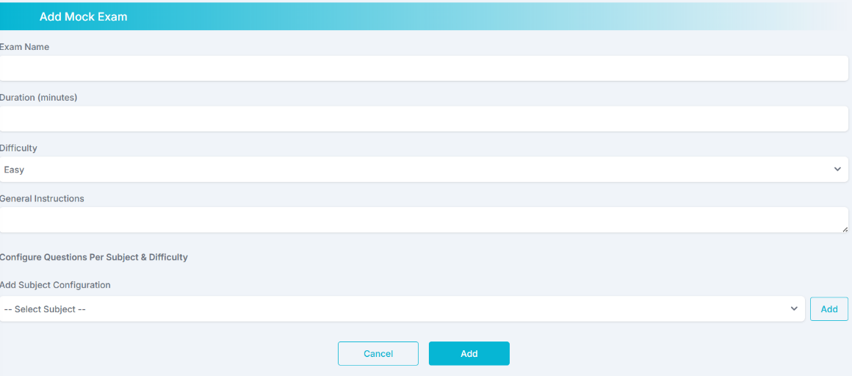
- API: /adminAddMockExam
- Methods: 'GET', 'POST'
- Function: adminAddMockExam()
- Request: name
difficulty
duration

52
instructions
config
- Response: subjects=subjects
3.11.7 Edit Mock Exam
- API: /adminEditMockExam
- Methods: 'GET', 'POST'
- Function: adminEditMockExam(exam_id)
- Request: exam_id
- Response: exam=exam, configs=configs, subjects=subjects
3.11.8 Delete Mock Exam
- API: /deleteMockExam
- Methods: 'POST'
- Function: delete_mock_exam()
- Request: q_id
- Response:

3.12 Logout
3.12.1 Overview
The Admin logout icon includes a logout confirmation popup for user safety.
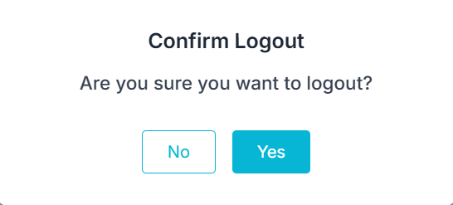

- API: /logout
- Methods:'GET'
53
- Function: logout()
- Request: user_id
- Response: session.pop('user_id', None

4. Institution

4.1 Navbar

Institution navbar totally consists of ,

- Dashboard
- Performance analysis


- Exam info
- Profile
- Logout
4.2 Dashboard
4.2.1 Overview
The Institution Dashboard is designed for institutions to monitor and evaluate student performance, and upcoming examinations. The dashboard provides a comprehensive overview of mock test results, daily practice scores, and custom module performance. It also supports real-time updates through REST API endpoints, giving institutions insights into averages, performance improvement needs and top performing.
4.2.2 Mock Tests
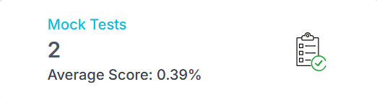
a
b
Displays the total number of mock tests taken by students and their average scores.

54
- API: /InstitutionDashboard
- Methods:'GET', 'POST'
- Function: inst_mocktest_details(id_tuple)
- Request: user_id
- Response: mock_tests_total_count=mock_tests_total_count, //a
mock_avg = mock_avg, //b
4.2.3 Daily Practice
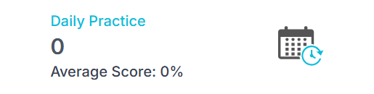
Displays the total number of daily practice taken by students and their average scores.
- API: /InstitutionDashboard
- Methods: 'GET', 'POST'
- Function: inst_daily_details(id_tuple)
- Request: user_id
- Response: daily_practice_total_count=daily_practice_total_count
daily_avg= daily_avg

4.2.4 Custom module
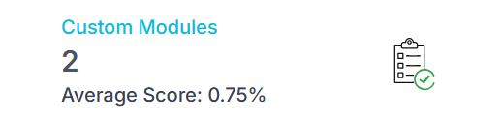
a
b
Displays the total number of custom modules taken by students and their average scores.
- API: /InstitutionDashboard
- Methods: 'GET', 'POST'
- Function: inst_custom_details(id_tuple)
55
- Request: user_id
- Response: custom_modules_total_count=custom_module_total_count
custom_avg = custom_avg
4.2.5 Performance Report
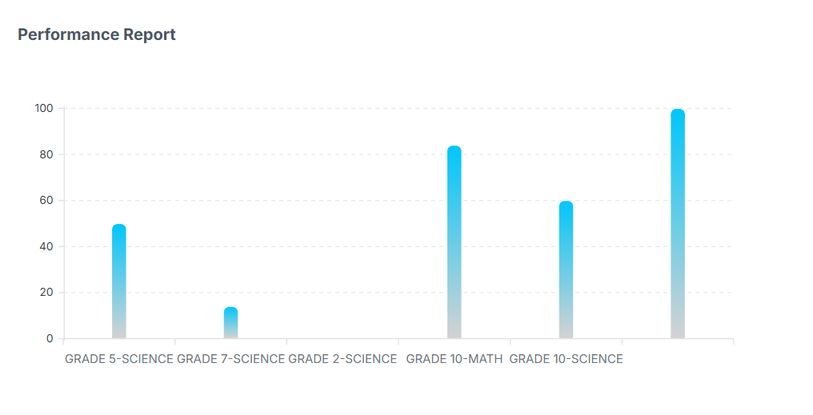
A visual bar chart representation of student performance metrics across various categories such as mock, daily practice, and custom modules.
- API: /InstitutionDashboard
- Methods: 'GET', 'POST'
- Function: inst_BarChartData(table, student_ids)
- Request: user_id
- Response: retBarChartData=retBarChartData.get_json()

4.2.6 Students Performance
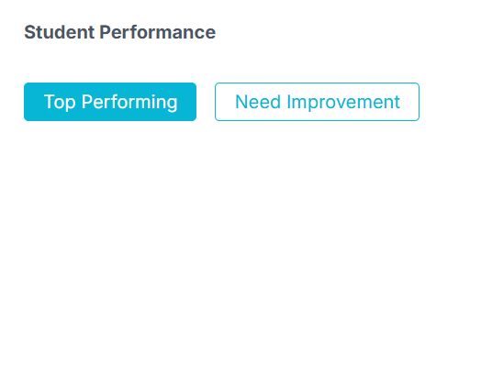
56
Displays lists of students categorized as top performers and those needing improvement based on average test scores.
- API: /InstitutionDashboard
- Methods: 'GET', 'POST'
- Function: inst_get_average_scores(id_tuple)
- Request: user_id
- Response: exams=all_filtered_exams,
top_students=top_students,
low_students=low_students

4.2.7 Mock Test pie chart
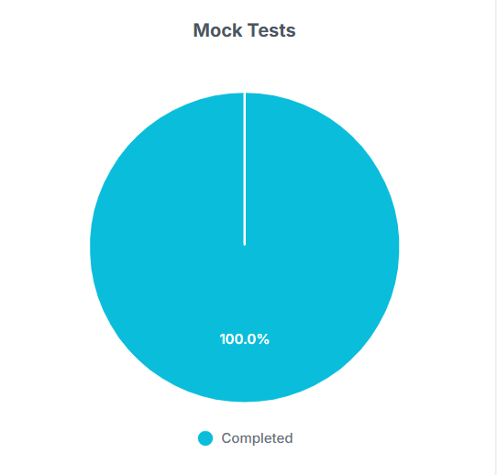
- API: /InstitutionDashboard
- Methods: 'GET', 'POST'
- Function: inst_mock_PieChartData(student_ids)
- Request: user_id
- Response: retPieChartMockData=retPieChartMockData.get_json()

57
4.2.8 Daily Practice pie chart
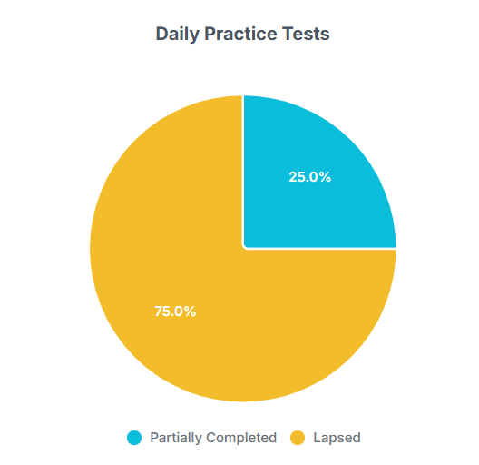
- API: /InstitutionDashboard
- Methods: 'GET', 'POST'
- Function: inst_daily_PieChartData(student_ids)
- Request: user_id
- Response: retPieChartDailyData=retPieChartDailyData.get_json()

4.2.9 Custom Module pie chart
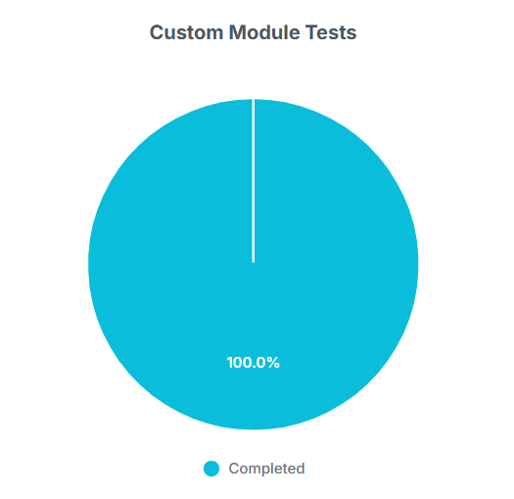
58
- API: /InstitutionDashboard
- Methods: 'GET', 'POST'
- Function: inst_custom_PieChartData(student_ids)
- Request: user_id
- Response: retPieChartCustomData=retPieChartCustomData.get_json()

4.2.10 Upcoming Exams

Displays the upcoming examinations assigned to the institution.

4.2.11 Exam Information:
The exam information allows administrators to filter exams by year and category and shows the exams that matches your interest, and gives details about the exam pattern, how the platform helps you to prepare and the exam calendar.
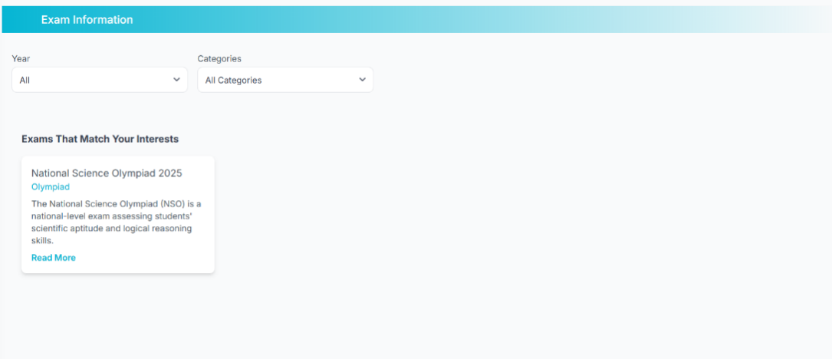
- API: /ExamInfoInstitutionDashboard
- Methods: ’GET’
59
- Function: examInfoInstitutionDashboard()
- Request:
- Response: year_options=year_options,categories=categories_data,exams=
exams
Filter by,
1.Year
2.Categories
- API: filter_exams_inst
- Methods: 'POST'
- Function: filter_exams_inst()
- Request: year
categories
- Response: exams=exams

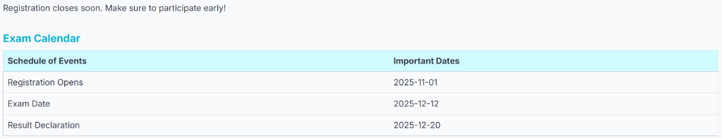
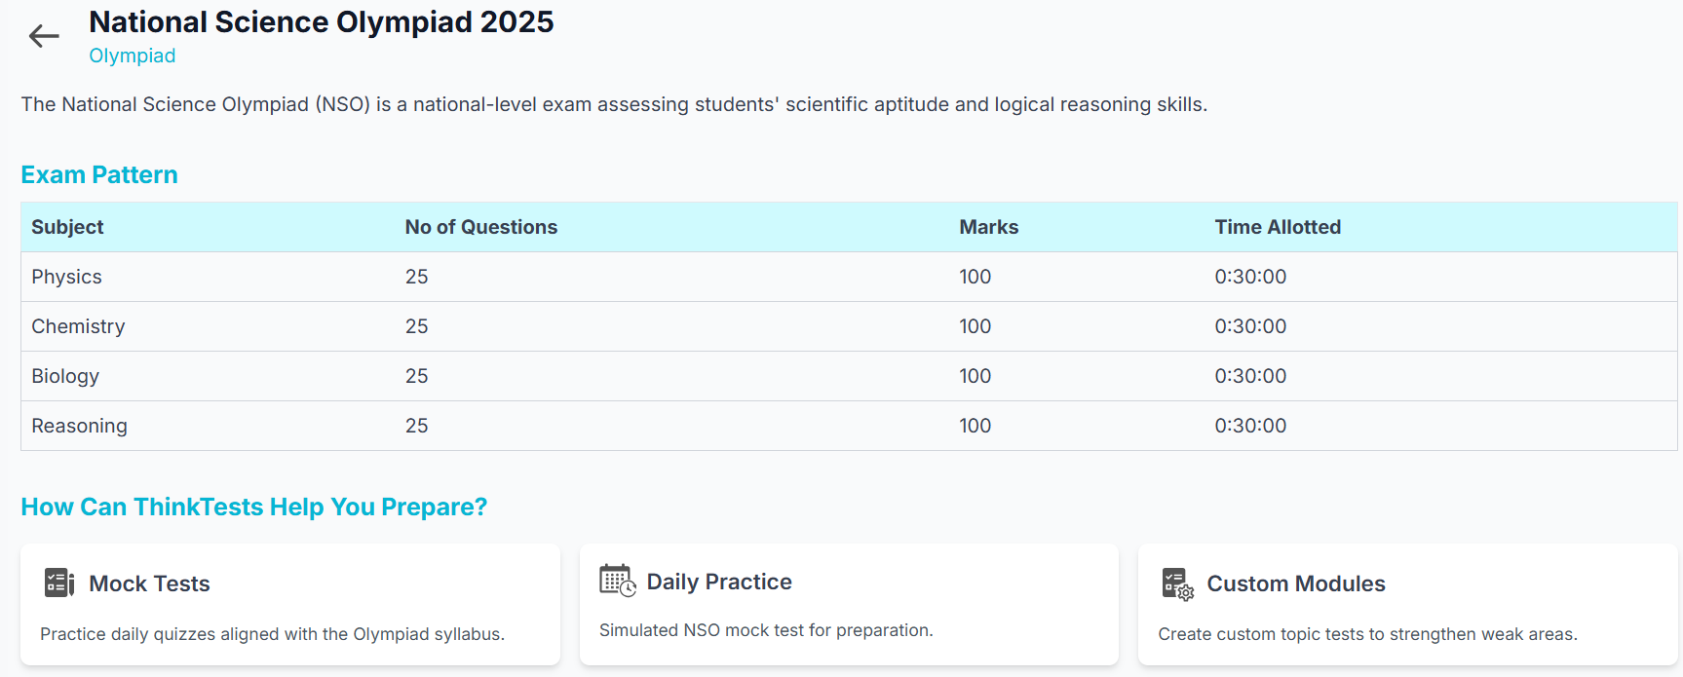

- API: /ExamInstitutionDetails
- Methods: ‘GET’
- Function: exam_institution_details()
- Request: exam_id

60
- Response: exam=exam, exam_pattern=exam_pattern,exam_calendar=
exam_calendar,exam_prepare=exam_prepare

4.3 Performances Analysis
4.3.1 Overview
The Performance Analysis Dashboard enables institutions to evaluate and monitor student performance across Mock Tests, Daily Practice Modules, and Custom Modules.
It provides an exam attempted ,average score by subject and average score by difficulty level.
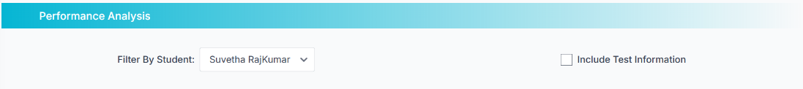
Filter by ,
1.Student

Include Test Information ,
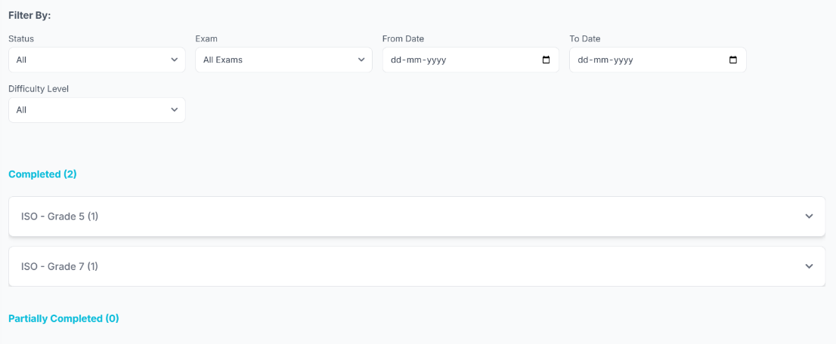

61
4.3.2 Mock Test
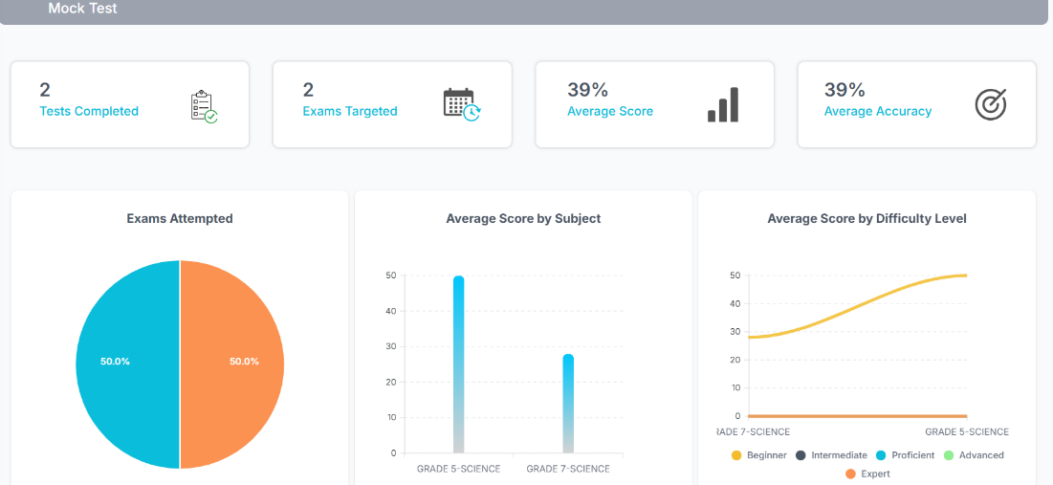
- API:
- Methods:
- Function:
- Request:
- Response:
4.3.3 Filter Mock Test
- API: /pa_filter_mocktest
- Methods: ’POST’
- Function: pa_filter_mocktest()
- Request: student_id
status
exam
from_date
to_date
difficulty
- Response: exam_attempt_details_completed=filtered_completed_attempts,
exam_attempt_details_incomplete=filtered_incomplete_attempts

62

4.3.4 Daily Practice
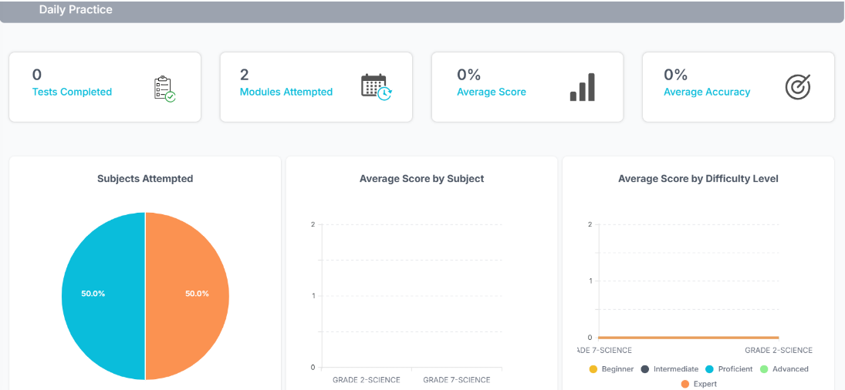
- API:
- Methods:
- Function:
- Request:
- Response:
4.3.5 Filter Daily Practice
- API: /pa_filter_dp
- Methods: 'POST'
- Function: pa_filter_dp()
- Request: student_id
status
subject
from_date
to_date
difficulty
- Response: dp_attempt_details_completed=filtered_completed_attempts,dp_
attempt_details_incomplete=filtered_incomplete_attempts,dp_attempt_
details_lapsed=filtered_lapsed_attempts, difficulty_map = difficulty_map

63

4.3.6 Custom Modules
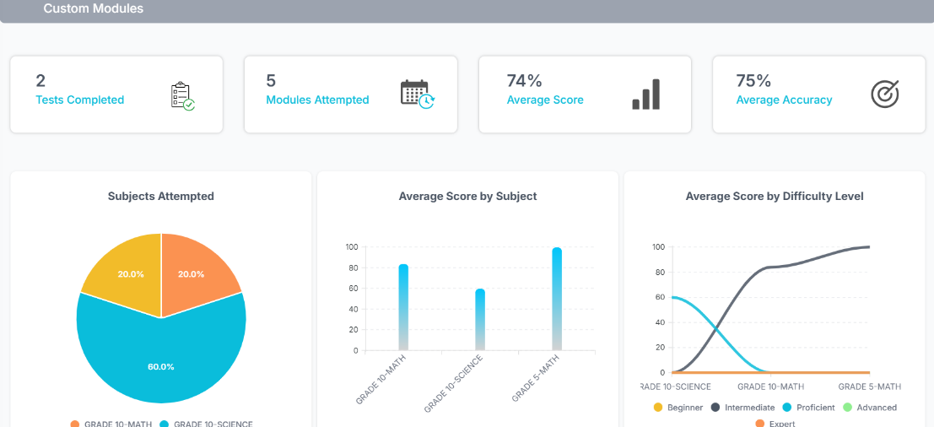
- API:
- Methods:
- Function:
- Request:
- Response:
4.3.7 Filter Custom Module
- API: /pa_filter_custommodule
- Methods: ’POST’
- Function: pa_filter_custommodule()
- Request: : student_id
status
subject
from_date
to_date
difficulty
- Response:custom_attempt_details_completed=filtered_completed_attempts,
custom_attempt_details_incomplete=filtered_incomplete_attempts,
difficulty_map = difficulty_map

64
4.4 Exam Information
4.4.1 Overview
The exam information allows administrators to filter exams by year and category and shows the exams that matches your interest, and gives details about the exam pattern, how the platform helps you to prepare and the exam calendar.
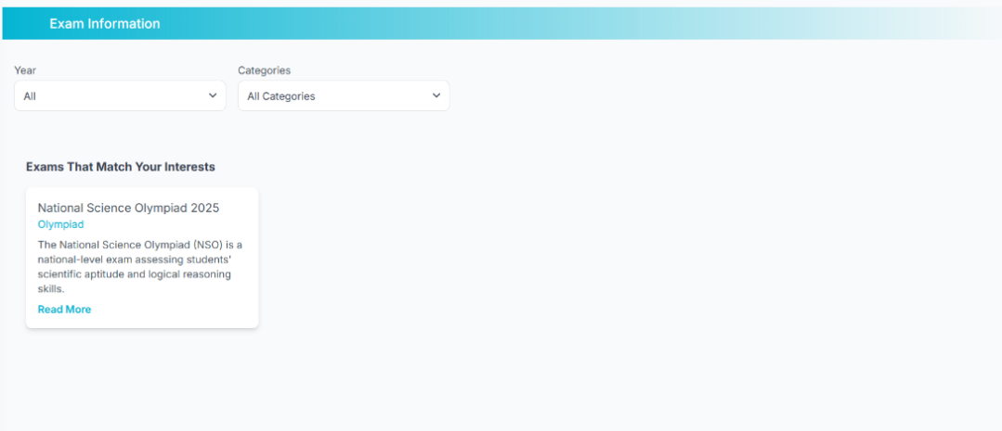

- API: /ExamInfoInstitutionDashboard
- Methods: ’GET’
- Function: examInfoInstitutionDashboard()
- Request:
- Response: year_options=year_options,categories=categories_data,exams=
exams
Filter by,
1.Year
2.Categories
- API: filter_exams_inst
- Methods: 'POST'
- Function: exam_institution_details()
- Request: year
categories
- Response: exams=exams

65
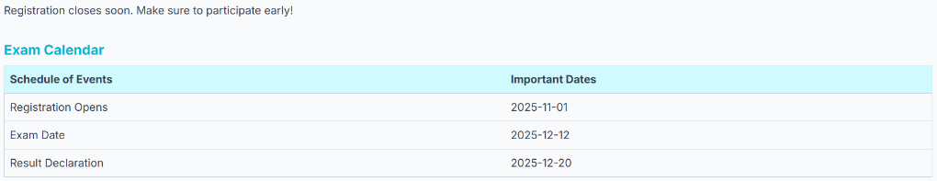


- API: /ExamInstitutionDetails
- Methods: 'POST'
- Function: exam_institution_details()
- Request: exam_id
- Response: exam=exam, exam_pattern=exam_pattern,exam_calendar=
exam_calendar,exam_prepare=exam_prepare

4.5 Profile
4.5.1 Overview
The Institution Profile allows institutional users to view and manage their organization’s account details like institution name, contact number, enrolment date, contact number, email address, plan, status, address, and total number of students. This page provides editable institution information fields like institution name, number, and address, also has password reset workflows with OTP verification.

66
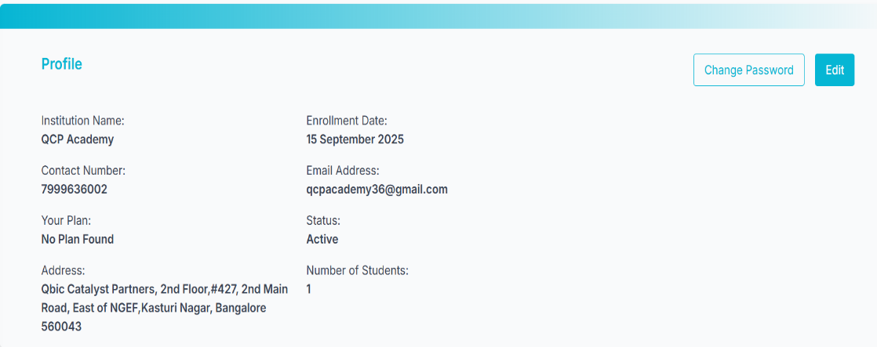
- API: /InstitutionProfile
- Methods: ‘POST’ , ‘GET’
- Function: instprofile()
- Request: user_id
- Response: user=user,
subscription=subscription,
inst_student_count=inst_student_count
For Edit,
- API: /saveinstprofile
- Methods: 'POST'
- Function: saveinstprofile()
- Request: user_id
Institution
phone
address
- Response:

67
4.6 Logout
4.6.1 Overview
The Institution logout icon includes a logout confirmation popup for user safety.


- API: /logout
- Methods: 'GET'
- Function: logout()
- Request: user_id
- Response: session.pop('user_id', None)

5.0 - USER

5.1 Navbar

User navbar totally consists of ,

- Dashboard
- Mock Test


- Daily Practice
- Custom Module


- Exam info
- Profile
- Logout
68
5.2 Dashboard
5.2.1 Overview
The Dashboard page provides a visual summary of activities such as the total number of mock tests, daily practices, and custom modules. The page also includes data visualization through interactive (bar and pie charts), performance report, displays upcoming exams, and integrates a calendar for scheduled activities for daily practice tests and shows the daily practice test scheduled for the current day. Users can quickly access scheduled tests, monitor performance metrics, and navigate to related pages for detailed insights.
5.2.2 Mock Test
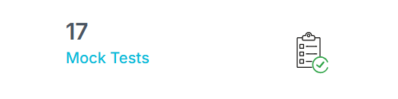
Displays the total number of mock tests taken by students.
- API: /Dashboard
- Methods: 'GET', 'POST'
- Function: dashboard()
- Request: user_id
- Response: mock_tests_total_count=mock_tests_total_count

5.2.3 Daily Practice
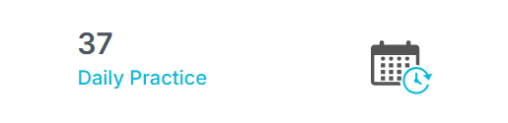
Displays the total number of daily practice taken by students.

69
- API: /Dashboard
- Methods: 'GET', 'POST'
- Function: dashboard()
- Request: user_id
- Response: daily_practice_total_count=daily_practice_total_count

5.2.4 Custom Modules
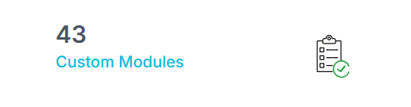
Displays the total number of custom modules taken by students.

- API: /Dashboard
- Methods: 'GET', 'POST'
- Function: dashboard()
- Request: user_id
- Response: custom_modules_total_count=custom_modules_total_count

5.2.5 Take Test
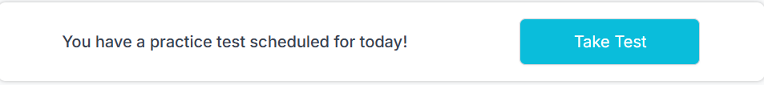

70

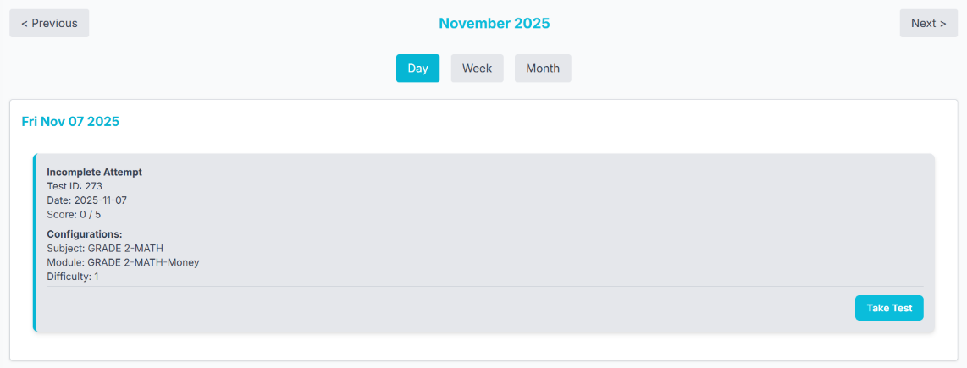
Takes to the daily practice test which has been scheduled for the current day.
- API: /DailyPracticeCalendar
- Methods: 'GET', 'POST'
- Function: view_schedule_calendar()
- Request: user_id
- Response: //Redirecting

- API: /dc_fetch_attempts
- Methods: 'GET', 'POST'
- Function: dc_fetch_attempts()
- Request: user_id
from_date
to_date
- Response: tests_completed, incomplete_tests, lapsed_tests

5.2.6 My Scheduled

71
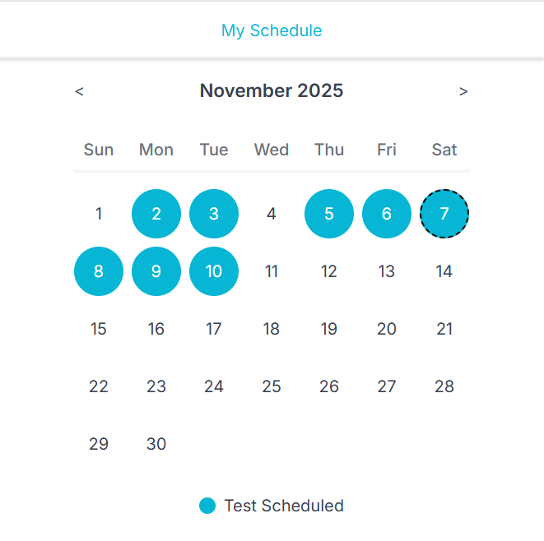
Shows the calendar view of daily practice test scheduled
- API: /Dashboard
- Methods: 'GET', 'POST'
- Function: dashboard()
- Request: user_id
- Response: daily_practice_scheduled_today=daily_practice_scheduled_today
daily_schedule_dates=dailyScheduleDates, exams = your_exams

5.2.7 Performance Report
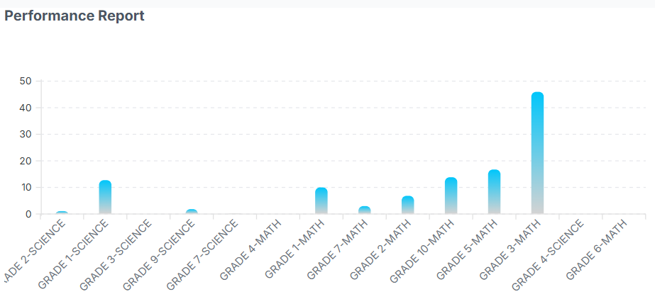

- API: /DashboardBarChartData
- Methods: 'GET'
72
- Function: get_dash_BarChartData()
- Request: user_id
- Response: series
5.2.8 Mock Test Pie Chart
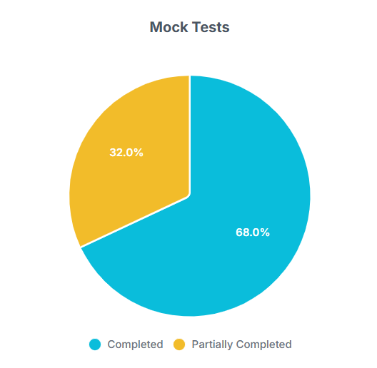
- API: /DashboardpieChartMockData
- Methods: 'GET'
- Function: get_mock_PieChartData()
- Request: user_id
- Response: pieChartData
5.2.9 Daily Practice Pie Chart
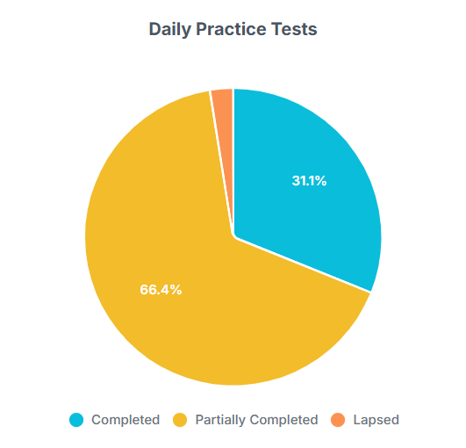

73
- API: /DashboardpieChartDailyData
- Methods: 'GET'
- Function: get_daily_PieChartData()
- Request: user_id
- Response: pieChartData

5.2.10 Custom Modules Chart
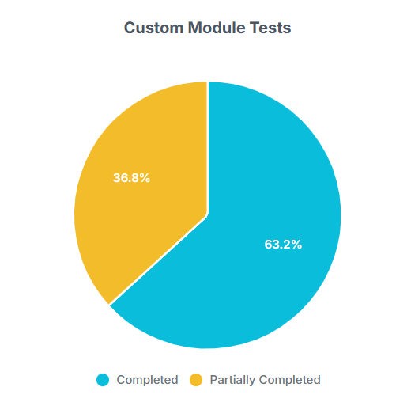
- API: /DashboardpieChartCustomData
- Methods: 'GET'
- Function: get_custom_PieChartData()
- Request: user_id
- Response: pieChartData

5.2.11 Upcoming Exams
Exam Information:
The exam information allows users to filter exams by year and category and shows the exams that matches your interest, and gives details about the exam pattern, how the platform helps you to prepare and the exam calendar.
74

- API: /ExamInfoDashboard
- Methods: ’GET’
- Function: examInfoDashboard()
- Request: user_id
- Response: year_options=year_options,categories=categories_data,your_
exams=your_exams,other_exams=other_exams)

Filter by,
1.Year
2.Categories
- API: /filter_exams
- Methods: 'POST'
- Function: filter_exams_inst()
- Request: user_id
year
categories
- Response: your_exams=your_exams,other_exams=other_exams

75




- API: /ExamDetails
- Methods: ‘GET’
- Function: exam_details()
- Request: exam_id
- Response: exam=exam,exam_pattern=exam_pattern,
exam_calendar=exam_calendar,exam_prepare=exam_prepare

5.3 Mock Test
5.3.1 Overview
The Mock Test Dashboard is designed to give users a visual overview of their mock test performance. It shows number of mock test completed, exams targeted, avg score and accuracy. Different chart data represents exam attempted, avg subject score and difficulty level. Shows completed test and partially completed test and able to view the report of the tests.
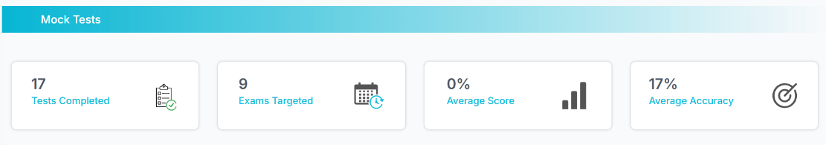
76
- API: /MockTestDashboard
- Methods: ‘GET’ ,’POST’
- Function:mockTestDashboard()
- Request: user_id
exam_name
difficulty
- Response:exams=exam_names.keys(), difficulty_levels=difficulty_levels,
mocks_completed=mocks_completed,average_accuracy=
average_accuracy,average_score=average_score,unique_
exams=unique_exams,exam_attempt_details
exam_attempt_details_completed=filtered_completed_
attempts,exam_attempt_details_incomplete=filtered_incomplete_
attempts, student_name=student_name,exams_targeted=
distinct_exams_count

5.3.2 Exams Attempted
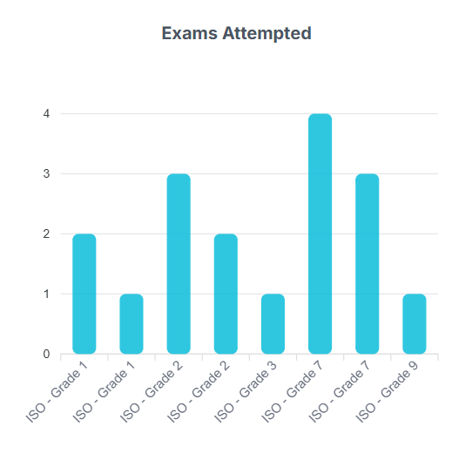
- API: /PieChartData //API is not secured
- Methods: ‘GET’
- Function: get_PieChartData()
- Request: exam_attempt_details
- Response: labels
series
pieChartData
77
5.3.3 Average Score by Subject

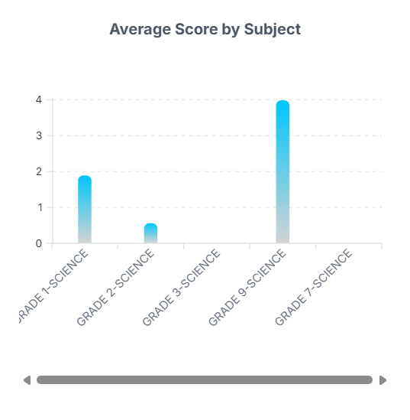
- API: /BarChartData //error
- Methods: ‘GET’
- Function: get_BarChartData()
- Request: exam_attempt_details
- Response: Series

5.3.4 Average Score by Difficulty Level

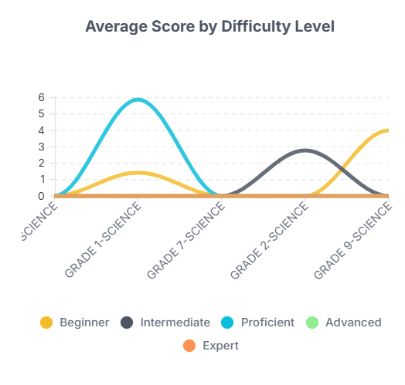
- API: '/LineChartData //error
- Methods: ‘GET’
- Function: get_LineChartData()
78
- Request: exam_attempt_details
- Response: labels
series
lineChartData

Filter System ,
- Status
- Exam
- From date
- To date
- Difficulty Level

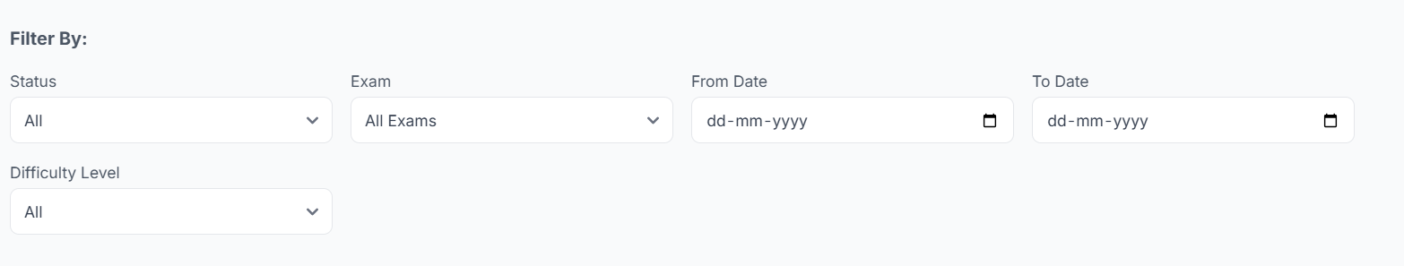
- API: /filter_mocktest
- Methods: ’POST’
- Function: filter_mocktest()
- Request: status
exam
from_date
to_date
difficulty
- Response: exam_attempt_details_completed=filtered_completed_attempts,exam_
attempt_details_incomplete=filtered_incomplete_attempts)

5.3.5 Completed test & Partially Completed

79
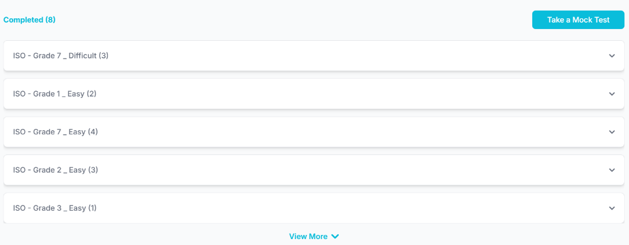
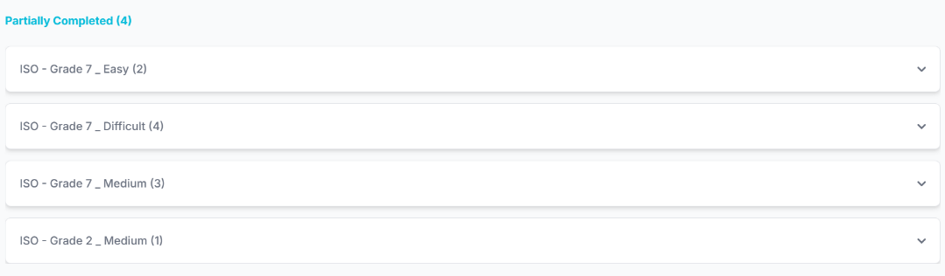

- API: /LineChartData
- Methods: ‘GET’
- Function: filter_mocktest_logic
- Request: student_id, status, exam_id, from_date, to_date, difficulty
- Respose: filtered_completed_attempts,filtered_incomplete_attempts

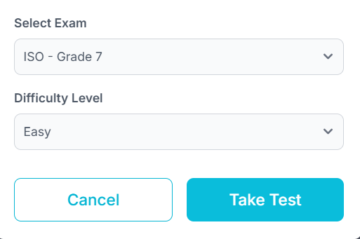

5.3.6 MockTest Create
- API: /MockCreateTest

80
- Methods: ‘POST’
- Function: mockCreateTest()
- Request: exam_id
- Response: attempt_id=attempt_id

5.3.7 TakeTest
- API: /MockTest
- Methods: ‘GET’ , ‘POST’
- Function: mockTest()
- Request: attempt_id
- Response: exam_id=exam_id,questions=questions,exam_duration=exam_
duration_seconds,attempt_id=attempt_id,
resume_seconds=resume_seconds)

5.3.8 Mocktest Instruction

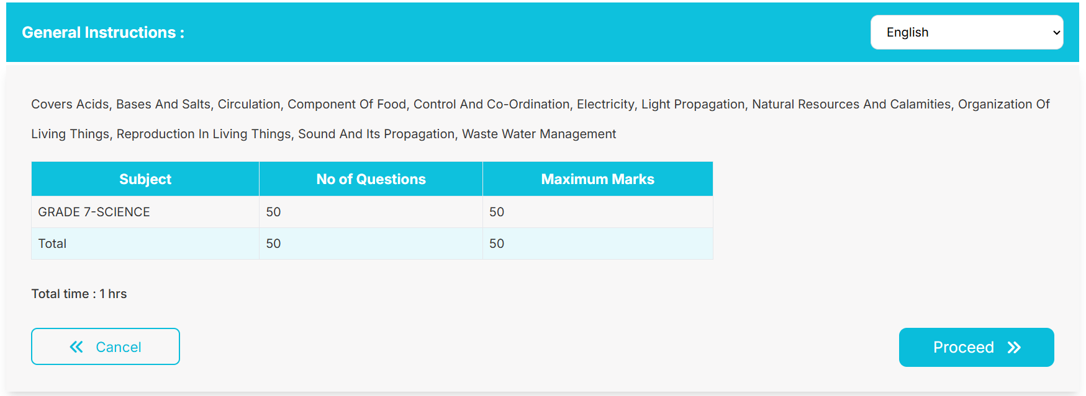
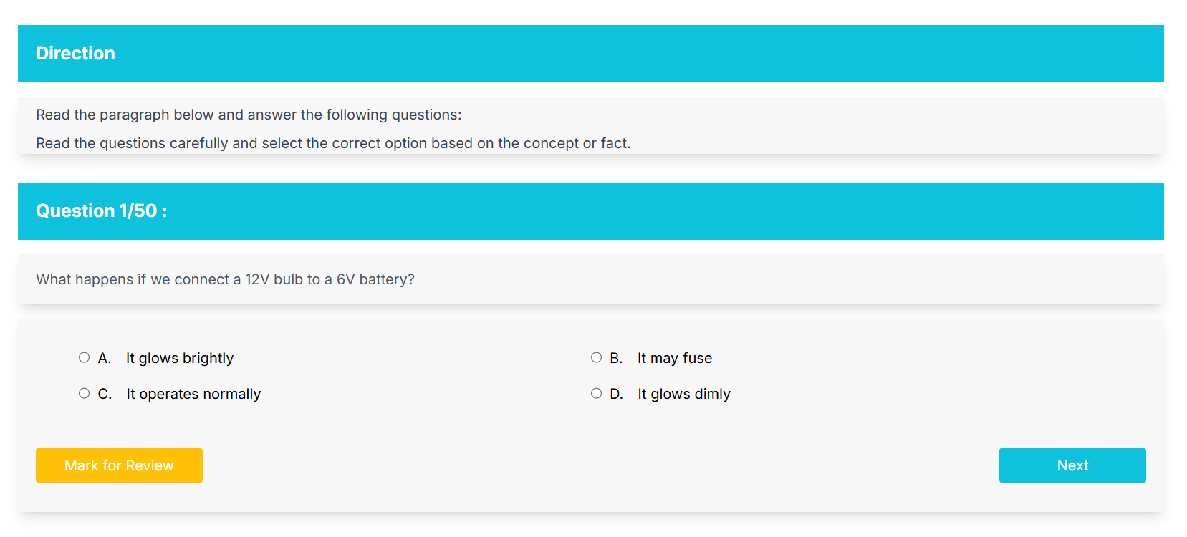
81
- API: /MockTestInstruction
- Methods: ‘POST’
- Function: mockTestInstruction()
- Request: user_id
- Response: exam=exam,
subjects=subjects,
total_questions=total_questions,
total_marks=total_marks,
exam_id=exam_id,
hours=hours,
minutes=minutes

5.3.9 Submit Mocktest

- API: /SubmitMockTest
- Methods: ’GET’ , ‘POST’
- Function: submit_Mocktest()
- Request: user_id
- Email Notification: "🎯 Your Mock Test Results Are Ready!"
- Response: "success": True,
"attempt_id": attempt_id,
"score": total_score,
"correct": correct_count,
"incorrect": incorrect_count,
"skipped": skipped_count,
"max_score": max_score

82

5.3.10 Report
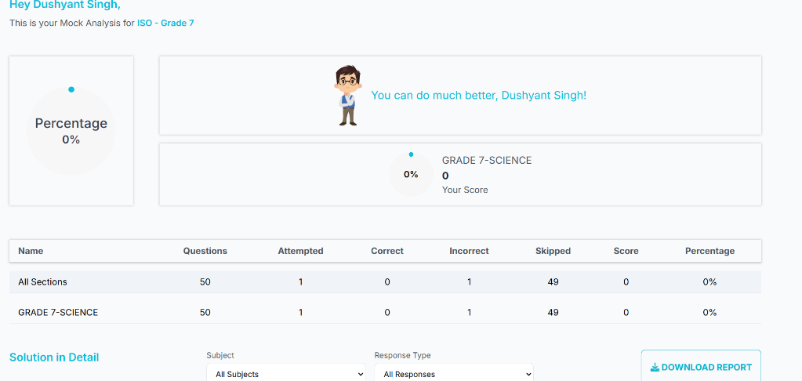

- API: /Report
- Methods: ’GET’ , ‘POST’
- Function: generateReport()
- Request: attempt_id
- Response: subjects=subjects,
all_sections=all_sections,
solutions=solutions,
exam_id=exam_id,
exam_name=exam_name,
student_id=student_id,
student_name=student_name,
date=date,
time=start_time,
attempt_id=attempt_id,
current_dashboard=current_dashboard,
page_type=page_type

5.3.11 FilterReport
- API: /filter_report
- Methods: ‘POST’
83

- Function: filter_report()
- Request: attempt_id
total_questions
subjects
responsetype
- Response: solutions = solutions, total_questions = total_questions

5.4 Daily Practice
3.4.1 Overview
The Daily Practice Test Dashboard is designed to give users a visual overview of their Daily Practce test performance. It shows number of test completed, exams targeted, avg score and accuracy. Able to schedule tests according to users comfort. Different chart data represents subjects attempted, avg subject score and difficulty level. Shows completed test , partially completed and lapsed test and able to view the report of the tests.
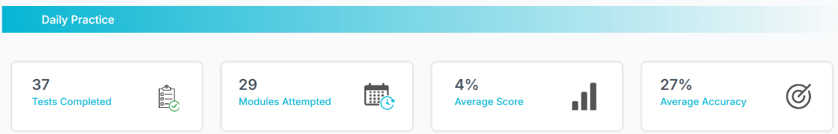
- API: /DailyPracticeDashboard
- Methods: ‘GET’ ,’POST’
- Function: dailyPracticeDashboard()
- Request: user_id
- Response:dp_attempt_details_completed=tests_completed_sorted,dp_attempt_
details_incomplete=incomplete_tests_sorted,dp_attempt_details_
lapsed=lapsed_tests_sorted, accuracy=accuracy,average=average,

84
student_name=student_name, modules_attempted_count=
modules_attempted_count, subjects=subjects, difficulty_map =
difficulty_map, modules=modules, all_subjects=all_subjects,
all_modules=all_modules

5.4.2 Subjects Attempted
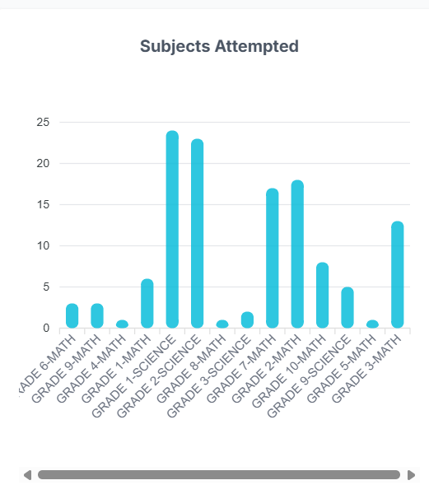

- API: /DailyPracticePieChartData //Api is not secured
- Methods: ‘GET’
- Function: get_DPPieChartData()
- Request: dp_attempt_ids
- Response: labels
series
pieChartData

85
5.4.3 Average Score by Subject
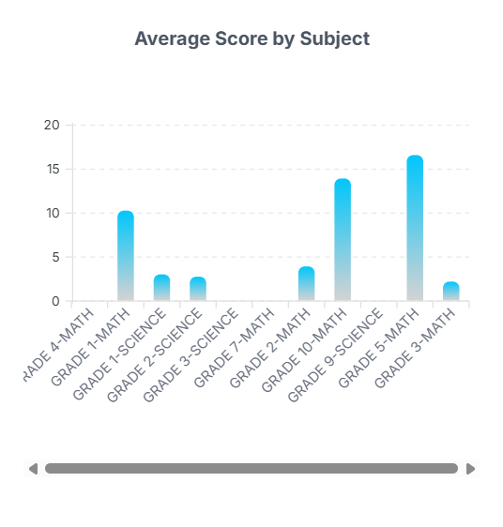

- API: /DailyPracticeBarChartData //error
- Methods: ‘GET’
- Function: get_DPBarChartData()
- Request: dp_attempt_ids
- Response: Series

5.4.4 Average Score by Difficulty Level


- API: /DailyPracticeLineChartData //Api is not secured
- Methods: ‘GET’
86
- Function: get_DPLineChartData()
- Request: dp_attempt_ids
- Response: : labels
series
lineChartData

5.4.5 View Schedule

- API: /DailyPracticeCalendar
- Methods: 'GET', 'POST'
- Function: view_schedule_calendar()
- Request: user_id
- Response:

- API: /dc_fetch_attempts
- Methods: 'GET', 'POST'
- Function: dc_fetch_attempts()
- Request: user_id
from_date
to_date
- Response: tests_completed, incomplete_tests, lapsed_tests

87

Filter System ,
- Status
- Subject
- From date
- To date
- Difficulty Level

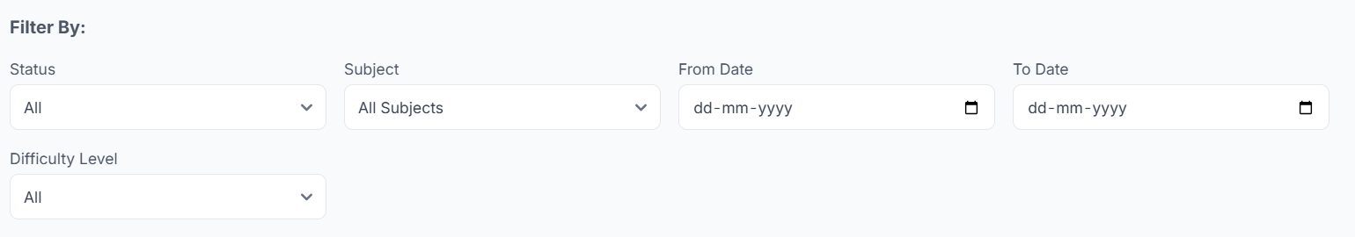
- API:/filter_dp
- Methods: ’POST’
- Function: filter_dp()
- Request: user_id
status
subject
from_date
to_date
difficulty
- Response: dp_attempt_details_completed=filtered_completed_attempts,dp_
attempt_details_incomplete=filtered_incomplete_attempts,
dp_attempt_details_lapsed=filtered_lapsed_attempts,
difficulty_map = difficulty_map)

88
5.4.6 Completed, Partially Completed & Lapsed

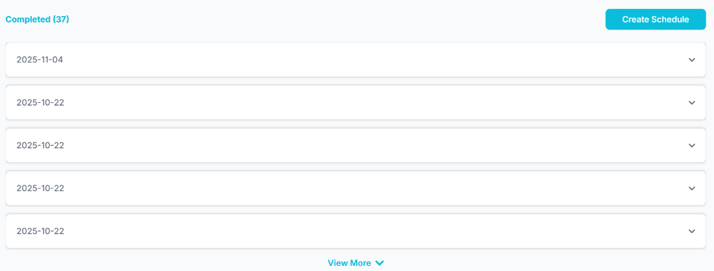
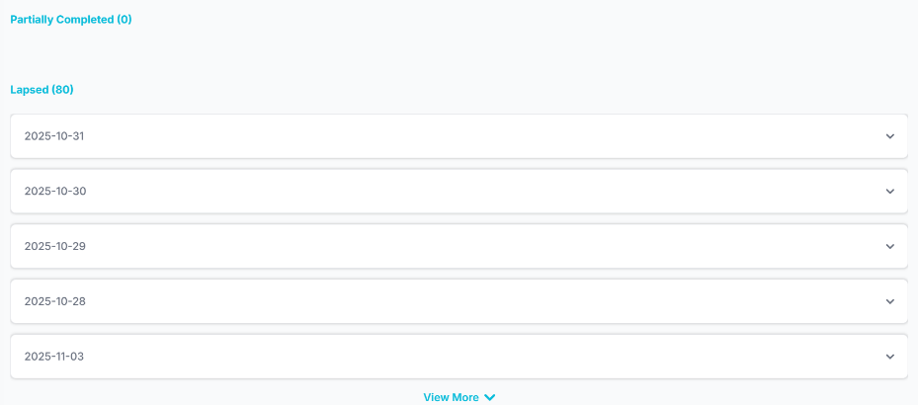
- API: /DailyPracticeDashboard
- Methods: ‘GET’
- Function:filter_dp_logic
- Request: student_id, status, subject_name, from_date, to_date, difficulty
- Response:filtered_completed_attempts,filtered_incomplete_attempts,
filtered_lapsed_attempts

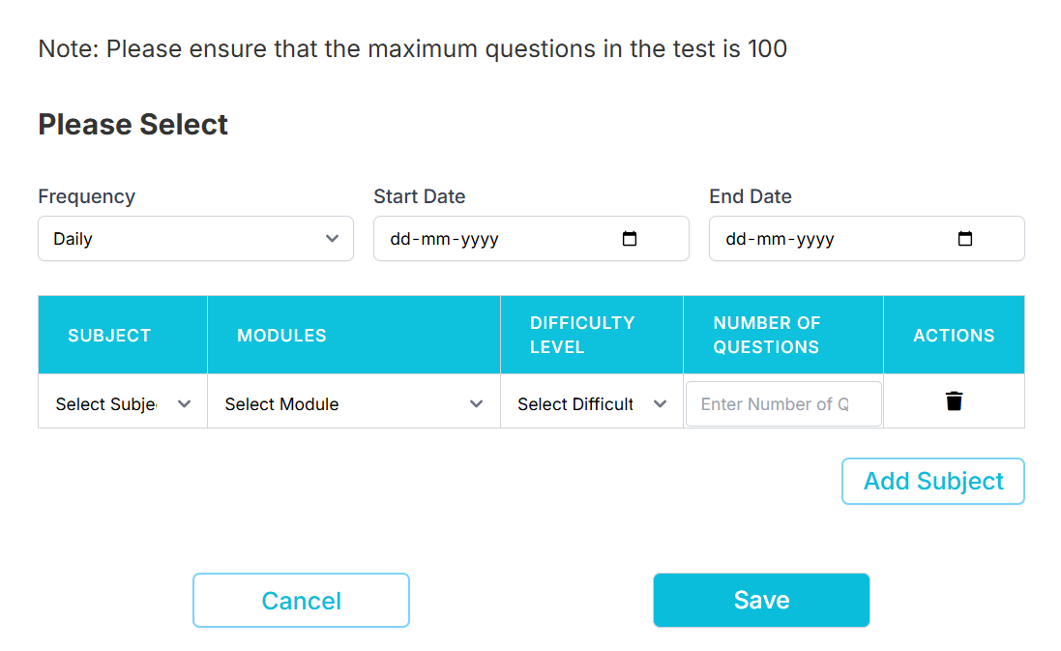
89
5.4.7 Create daily practice test
- API: /DailyPracticeCreateTest
- Methods: ‘POST’
- Function: dailyPracticeCreateTest()
- Request: schedulerdata
frequency
start_date
end_date
data
subject_name
module_id
module_name
difficulty_level
difficulty_name
question_count
- Response:

5.4.8 DailyPractice Test
- API: /DailyPracticeTest
- Methods: ‘GET’ , ‘POST’
- Function: dailyPracticeTest()
- Request: user_id
- Response: questions=questions, attempt_id=attempt_id

5.4.9 Delete dp attempt
- API: /delete_dp_attempt
- Methods: ‘POST’
- Function: delete_dp_attempt()
- Request: attempt_id
- Response:
90
5.4.10 Edit attempt date
- API: /dp_edit_attempt_date
- Methods: ‘POST’
- Function: dp_edit_attempt_date()
- Request: attempt_id
change_attempt_date
- Response:

5.4.11 DailyPractice Instruction

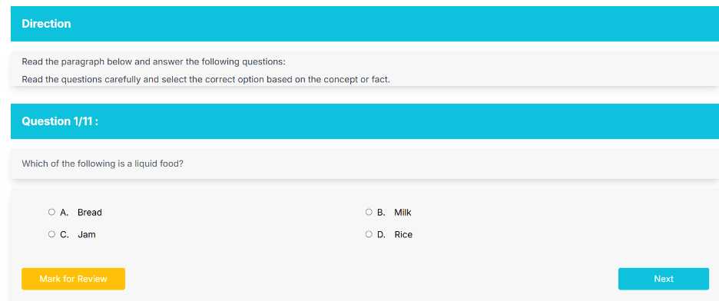

- API: /DailyPracticeInstruction
- Methods: ‘POST’
- Function: dailyPracticeInstruction()
- Request: configs
- Response: configs=dp_configs

5.4.12 Submit DailyPractice
- API: /SubmitDailyPractice
- Methods: ‘POST’
- Function: submitDailyPracticeModule()
- Request: user_id
attempt_id
91

selectedOptions
selectedOptionsForq_id
qIdToQOrder
questionStatus
partial_complete
- Email Notification: "📅 Your Daily Practice Test Has Been Scheduled!"
- Response:

5.4.13 Report

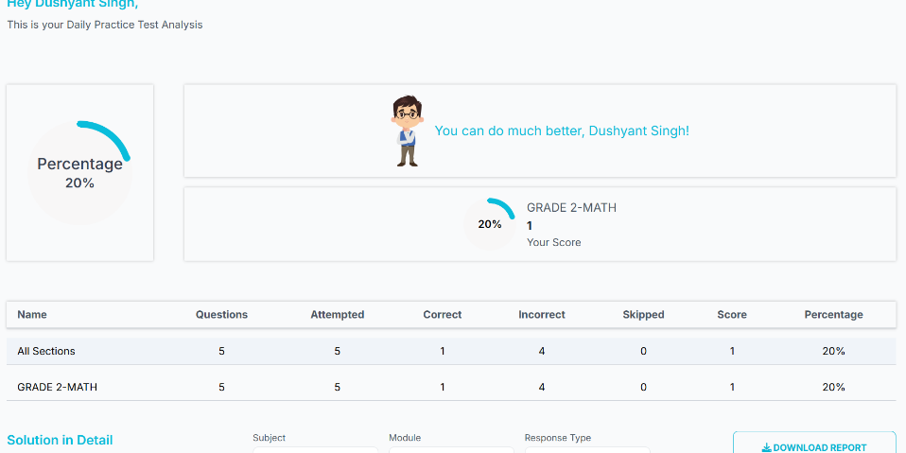

- API: /DailyPracticeReport
- Methods: ’GET’ , ‘POST’
- Function: dpGenerateReport()
- Request: attempt_id
- Response: current_dashboard=current_dashboard,
page_type=page_type,
subjects=subjects,
modules=modules,
all_sections=all_sections,
92
solutions=solutions,
student_id=student_id,
student_name=student_name,
date=date,
attempt_id=attempt_id

5.4.14 FilterReport
- API: /dp_filter_report
- Methods: ‘POST’
- Function: dp_filter_report()
- Request: attempt_id
total_questions
subjects
responsetype
- Response: solutions = filtered_solutions, total_questions = total_questions

5.5 Custom Modules
5.5.1 Overview
The custom module Dashboard is designed to give users a visual overview of their mock test performance. It shows number of test completed, exams targeted, avg score and accuracy. Different chart data represents subject attempted, avg subject score and difficulty level. Shows completed test and partially completed test and able to view the report of the tests
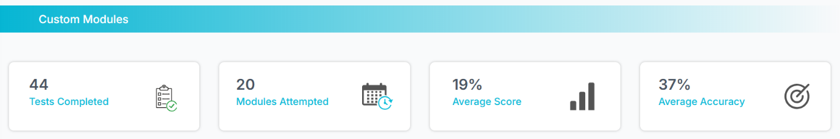
- API: /CustomModuleDashboard
93
- Methods: ‘GET’ ,’POST’
- Function: customModuleDashboard()
- Request: user_id
- Response: dp_attempt_details_completed=tests_completed_sorted,dp_attempt_
details_incomplete=incomplete_tests_sorted,dp_attempt_details_
lapsed=lapsed_tests_sorted, accuracy=accuracy,average=average,
student_name=student_name, modules_attempted_count=
modules_attempted_count, subjects=subjects, difficulty_map =
difficulty_map, modules=modules, all_subjects=all_subjects,
all_modules=all_modules

5.5.2 Subjects Attempted
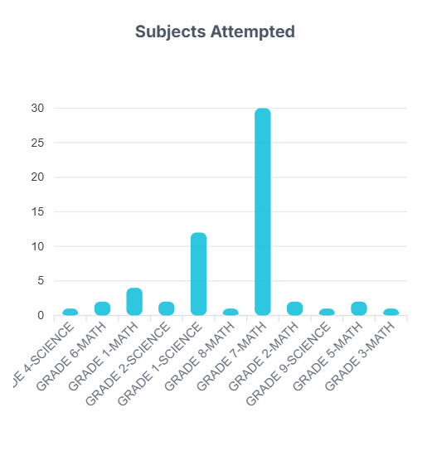
- API: /CustomModulePieChartData //Api is not secured
- Methods: ‘GET’
- Function: get_CMPieChartData()
- Request: custommodule_attempt_ids
- Response: labels
series
pieChartData

94
5.5.3 Average Score by Subject
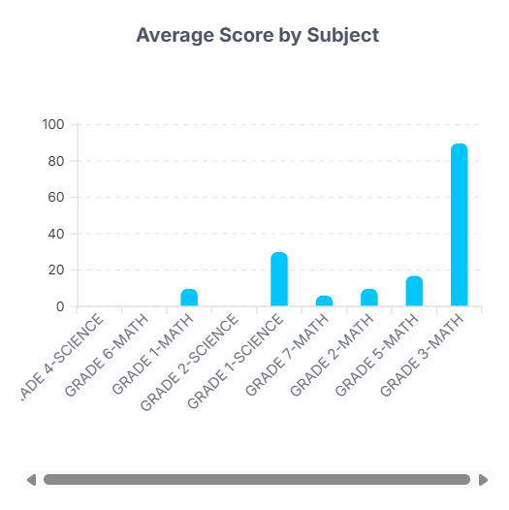

- API: /CustomModuleBarChartData //error
- Methods: ‘GET’
- Function: get_CMBarChartData()
- Request: custommodule_attempt_ids
- Response: Series

5.5.4 Average Score by Difficulty Level
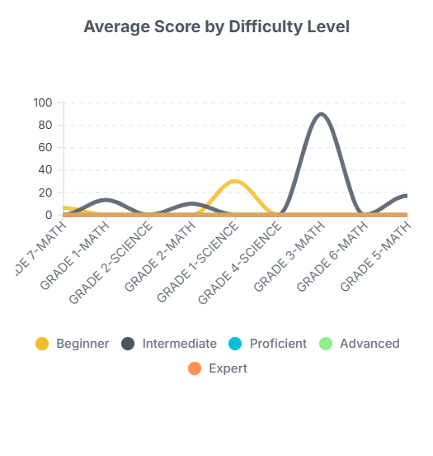

- API: /CustomModuleLineChartData //Api is not secured
- Methods: ‘GET’
- Function: get_CMLineChartData()
95
- Request: custommodule_attempt_ids
- Response: labels
series
lineChartData

Filter System ,
- Status
- Subject
- From date
- To date
- Difficulty Level



- API: /filter_custommodule
- Methods: ’POST’
- Function: filter_custommodule()
- Request: user_id
status
subject
from date
to date
difficulity
- Response:custom_attempt_details_completed=filtered_completed_attempts,
custom_attempt_details_incomplete=filtered_incomplete_
attempts, difficulty_map = difficulty_map

96
5.5.5 Completed & Partially completed

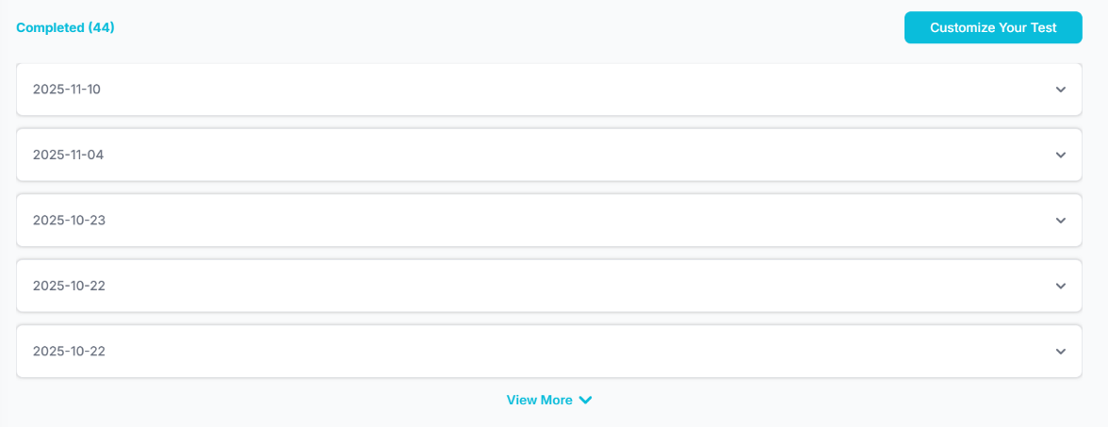
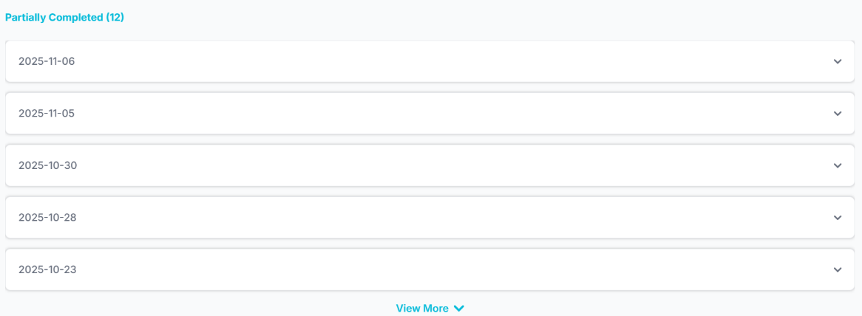
- API: /CustomModuleDashboard
- Methods: ‘GET’
- Function: filter_custommodule_logic
- Request: student_id, status, subject_name, from_date, to_date, difficulty
- Response: filtered_completed_attempts,filtered_incomplete_attempts

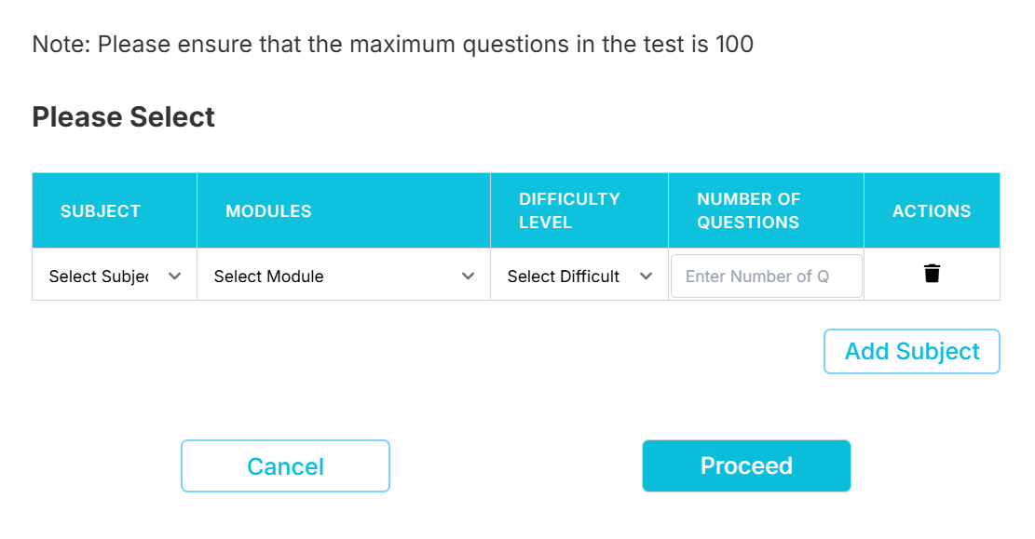

97
5.5.6 Create Custom Module test
- API: /CustomModuleCreateTest
- Methods: ‘POST’
- Function: customModuleCreateTest()
- Request: configs
- Response:

5.5.7 Custom Module Test
- API: /CustomModuleTest
- Methods: ‘GET’ , ‘POST’
- Function: customModuleTest()
- Request: attempt_id
- Response: questions=questions, attempt_id=attempt_id

5.5.8 Delete cm attempt
- API: /delete_custom_attempt
- Methods: ‘POST’
- Function: m_attempt()
- Request: attempt_id
- Response:

5.5.9 Custom Module Instruction

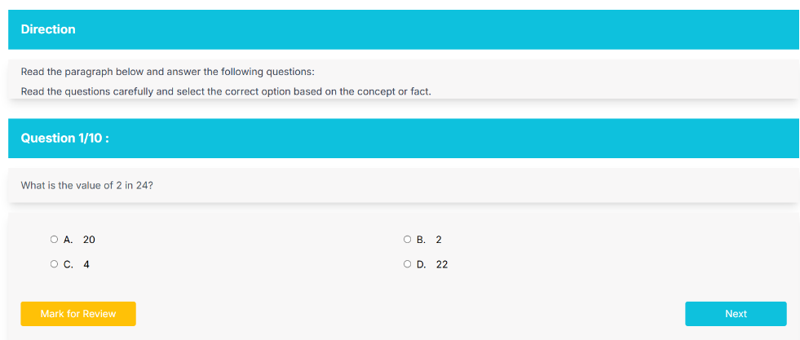

98
- API: /CustomModuleInstruction
- Methods: ‘POST’
- Function:customModuleInstruction()
- Request: data
configs
subject_id
subject_name
module_id
module_name
difficulty_level
difficulty_name
question_count
- Response: configs=custom_configs

5.5.10 Submit Custom Module
- API: /SubmitCustomModule
- Methods: ‘POST’
- Function: submitCustomModule()
- Request: user_id
attempt_id
selectedOptions
selectedOptionsForq_id
qIdToQOrder
questionStatus
partial_complete
- Email Notification: "✅ Custom Module Test Submitted Successfully!"
- Response:

99
5.5.11 Report
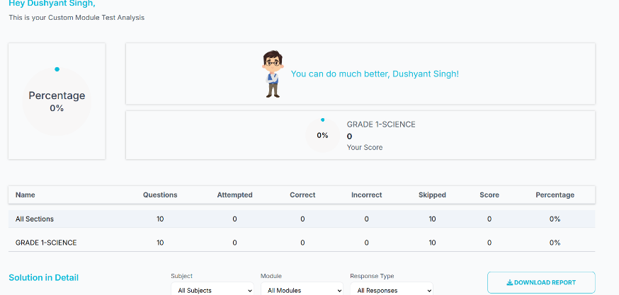
- API: /CustomModuleReport
- Methods: ‘GET‘ , ‘POST’
- Function: cmGenerateReport()
- Request: attempt_id
- Response: subjects=subjects,
modules=modules,
all_sections=all_sections,
solutions=solutions,
student_id=student_id,
student_name=student_name,
date=date,
attempt_id=attempt_id,
page_type=page_type,
current_dashboard=current_dashboard

5.5.12 FilterReport
- API: /cm_filter_report
- Methods: ‘POST’
- Function: cm_filter_report()
- Request: attempt_id
total_questions

100
subjects
modules
responsetype
- Response: solutions = filtered_solutions, total_questions = total_questions

5.6 Exam Information
5.6.1 Overview
The exam information allows users to filter exams by year and category and shows the exams that matches your interest, and gives details about the exam pattern, how the platform helps you to prepare and the exam calendar.

- API: /ExamInfoDashboard
- Methods: ’GET’
- Function: examInfoDashboard()
- Request: user_id
- Response: year_options=year_options,categories=categories_data,your_
exams=your_exams,other_exams=other_exams)

101
Filter by,
1.Year
2.Categories
- API: /filter_exams
- Methods: 'POST'
- Function: filter_exams_inst()
- Request: user_id
year
categories
- Response: your_exams=your_exams,other_exams=other_exams




- API: /ExamDetails
- Methods: ‘GET’
- Function: exam_details()
- Request: exam_id
- Response: exam=exam,exam_pattern=exam_pattern,
exam_calendar=exam_calendar,exam_prepare=exam_prepare

102
5.7 .Profile
5.7.1 Overview
The User Profile page allows users to view and manage their account details, including their first name, last name, gender, date of birth, institution name, enrolment date, contact number, email address, plan, and status. This page provides editable fields for the first name, last name, gender, date of birth, and contact number, which require OTP verification. It also includes sections for specifying user interests, such as preferred exams and subject areas and also has plan renew option.

5.7.2 Renew Plan
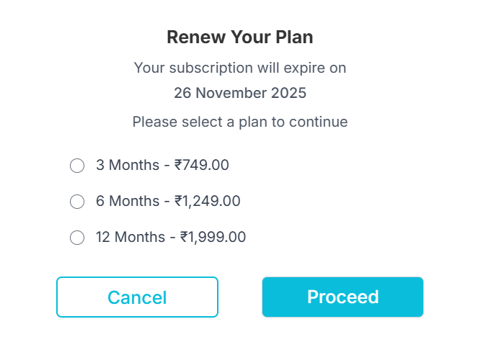
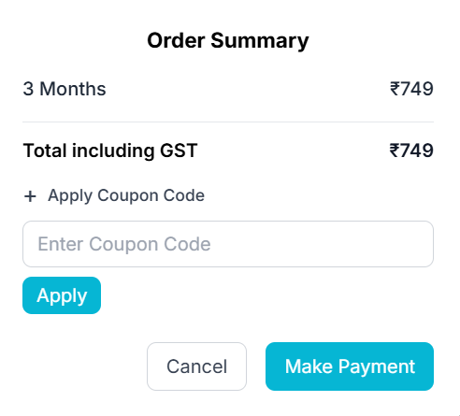
- API: /create_order
- Methods: ’POST’
103
- Function: create_order()
- Request: amount
- Response:
5.7.3 Apply Coupon
- API: /coupon/apply
- Methods: ’POST’
- Function: apply_coupon()
- Request: coupon_code
original_price
- Response: 'message': f'Coupon "{coupon_code}" applied successfully',
'original_price': original_price,
'discount_percent': float(coupon.discountpercent),
'discount_amount': round(discount_amount, 2),
'final_price': round(final_price, 2),
'code_id': coupon.codeid,
'usage_counter': coupon.usagecounter,
'usage_limit': coupon.usagecount

5.7.4 Payment
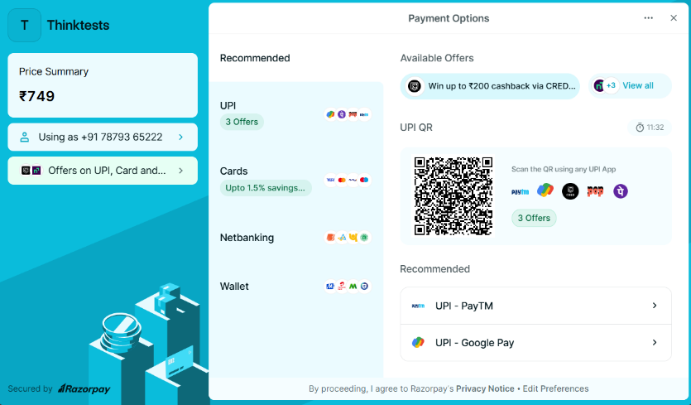
- API: /verify_payment
- Methods: ’POST’
104
- Function: verify_payment()
- Request: razorpay_payment_id
razorpay_order_id
razorpay_signature
- Response: success
failure

Get orders ,
- API: /orders
- Methods: ‘GET’
- Function: get_orders()
- Request: id
amount_paid
created_at
receipt
status
- Response: formatted_orders

5.7.5 Profile
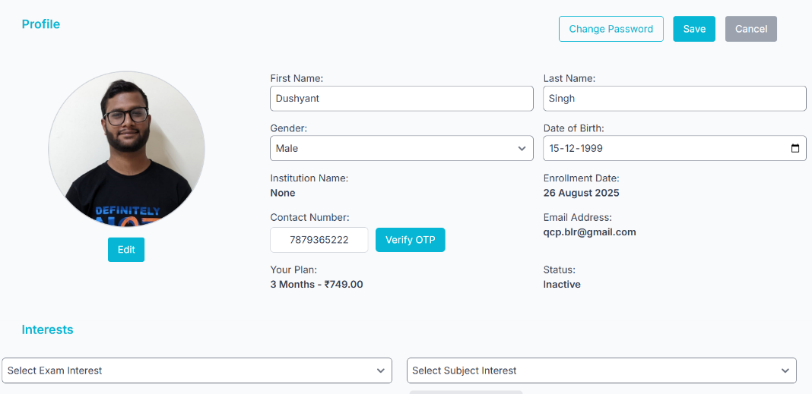
- API: /Profile
- Methods: ‘POST’ , ‘GET’
- Function: profile()
105
- Request: user_id
- Response: user=user,
subscription=subscription_data,
plan=plan_data,
exam_list=exam_list,
subject_list=subject_list,
selected_exam_interests=selected_exam_interests,
selected_subject_interests=selected_subject_interests,
institution_name=institution_name,
current_date=current_date,
profile_pic_url=profile_pic_url,
razorpaykey = application.config['RAZORPAY_ACCESS_KEY_ID'],
plans=plans,
last_subscription_date = last_subscription.end_date,
status=status,
user_institution_subscription=user_institution_subscription

For Edit,
- API: /saveprofile
- Methods: 'POST'
- Function: saveprofile()
- Request: user_id
first_name
last_name
gender
dob
institution_id
phone

106
exam_interests
subject_interests
- Response:
For upload Profile,
- API: /uploadProfilePic
- Methods: 'POST'
- Function: upload_profile_pic_dashboard()
- Request: student_id
- Response:

For delete Profile,
- API: /deleteProfilePic
- Methods: DELETE
- Function: delete_profile_pic(student_id)
- Request: student_id
- Response:

5.8 Logout
5.8.1 Overview
The user logout icon includes a logout confirmation popup for user safety.

107
- API: /logout
- Methods: 'GET'
- Function: logout()
- Request: user_id
- Response: session.pop('user_id', None)

108

